**GURU TEGH BAHADUR INSTITUTE OF TECHNOLOGY**



**WEB DEVELOPMENT USING MERN STACK**

**SUBJECT CODE: FSD-322P**

**SEMESTER – VI**

**Submitted to, Submitted by,**

**Ms. Kritika Name: Abhay Raj**

**Enrolment No: 00976803122**

**Branch: IT – 3 (FSD)**

**Batch: 2022-2026**

|  |  |  |  |
| --- | --- | --- | --- |
| S.No | Program | Date | Signature |
| 1. (a) | To Introduce the 3 tier architecture of mern stack. |  |  |
| 1. (b) | To elucidate the HTML elements |  |  |
| 2. (a) | To introduce CSS and its types |  |  |
| 2. (b) | Introduction to JavaScript and its types |  |  |
| 3. (a) | To create a time-table using HTML |  |  |
| 3. (b) | To create nested lists using HTML |  |  |
| 4. (a) | To create a registration form using HTML |  |  |
| 4. (b) | To create frames and hyperlinks using HTML |  |  |
| 5. (a) | Create a static website using HTML, CSS, and JavaScript |  |  |
| 5. (b) | Install and set up Node.JS and Express.JS |  |  |
| 6. | Set up React App and print “Hello World” |  |  |
| 7. | To make list components and table components |  |  |
| 8. (a) | To perform use state in React to alter the state of components |  |  |
| 8. (b) | Use props to send data between components |  |  |
| 9. | To create a server in Node.JS and Express.JS and send a get request. |  |  |
| 10. (a) | To install MongoDB Server and Mongosh on the local machine |  |  |
| 10. (b) | Create a MongoDB and perform CRUD operations on it |  |  |
| 11. | Task management tool: Login/Register to the application, add daily tasks, Assign a due date of completion, Mark them as complete/incomplete, and View weekly/monthly statistics of their to-dos. |  |  |
| 12. | Blogging platform |  |  |
| 13. | Social media platform |  |  |
| 14. | Weather Forecasting App |  |  |
| 15. | Bookstore Library and Stock-Keeping App |  |  |

**Experiment 1 (a)**

**Aim:-** To Introduce the 3 Tier architecture of Mern Stack.

Although there are many different stacks out there to consider, some have become

more common than others due to their popularity and ease of use. One of these

popular stacks is the MERN stack. Let us check out MERN stack full form which

consists of the following technologies:

1. M stands for MongoDB ( Database ) which is a Popular NoSQL (Non-Structured ‘

2. Query Language) Database System.

3. E stands for Express, A powerful middleware that sits on top of the server side Node.js

web APIs.

4. R stands for React, a client-side JavaScript Library renowned for developing rich user

experiences.

5. N stands for Node js, A premier JavaScript web server development environment that

is fast and efficient

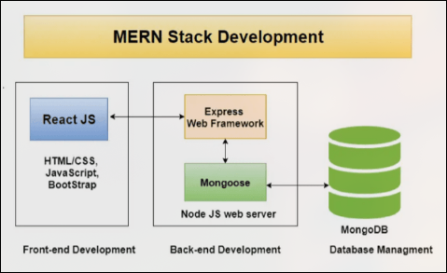

MERN Stack Components

MERN adheres to a 3-tier architecture system consisting of 3 layers

These layers are as follows:

1. Front-end tier for Web: Basically, the top tier of the MERN stack handled by

React.js, which is prominently used open-source front-end JavaScript library for

building Web applications

2. The middle tier is Server: The next level from top layer is handled by two

components of the stack, i.e., Express.js and Node.js. They handle it

simultaneously where Express.js maintains the server-side framework and

middleware, running inside the Node.js server.

3. Backend tier as Database: Being one of the most important levels of the

MERN Stack, it is handled by MongoDB. The main role of a database is to store all

your application-related data. It is the most popular NoSQL database.

**Experiment 1 (b)**

**Aim:-** To elucidate the HTML elements

An **HTML element** is the fundamental building block of a webpage, consisting of a **start tag, content, and an end tag**. Elements define the structure and behavior of web pages.

1. Basic Structure of an HTML Element

<tagname>Content</tagname>

Example:

<p>Hello, World!</p>

2. Types of HTML Elements

#### ****a) Block-Level Elements****

These elements take up the full width and start on a new line.

<h1>Heading</h1>

<p>Paragraph</p>

<div>Container</div>

These elements take up only as much width as necessary and do not start on a new line.

#### ****b) Inline Elements****

These elements take up only as much width as necessary and do not start on a new line.

<span>Text</span>

<a href="#">Link</a>

<strong>Bold</strong>

#### ****c) Void (Self-Closing) Elements****

These elements do not have closing tags.

#### ****<img src="image.jpg" alt="Image">****

**<input type="text">**

**<br>**

3. Commonly Used HTML Elements

a) Text Formatting Elements

b) List Elements

c) Table Elements

d) Form Elements

<!DOCTYPE html>

<html>

<head><title>HTML Example</title></head>

<body>

<h1>Welcome</h1>

<p><strong>HTML elements demo</strong></p>

<ul><li>Web Dev</li><li>App Dev</li></ul>

<img src="logo.png" alt="Logo" width="200">

<table border="1">

<tr><th>Service</th><th>Price</th></tr>

<tr><td>Web Dev</td><td>$500</td></tr>

</table>

<form>

<input type="text" placeholder="Name">

<input type="email" placeholder="Email">

<button>Submit</button>

</form>

</body>

</html>

Output:

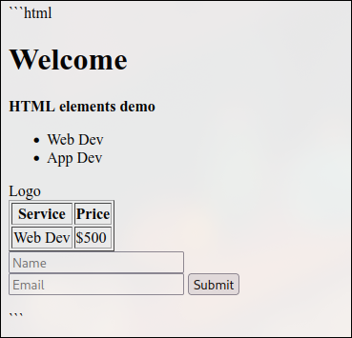

**Experiment 2 (a)**

**Aim:-** To introduce CSS and its types

CSS (**Cascading Style Sheets**) is used to **style** and **layout** web pages. It controls elements like colors, fonts, spacing, and positioning.

### ****Types of CSS****

1. **Inline CSS** (Applied directly to an element using the style attribute)

<p style="color: red; font-size: 20px;">This is inline CSS</p>

* + **Pros:** Quick, applies to a single element.
  + **Cons:** Hard to maintain, not reusable.

1. **Internal CSS** (Defined within a <style> tag in the <head> section)

<style>

p { color: blue; font-size: 18px; }

</style>

* + **Pros:** Styles multiple elements in a single file.
  + **Cons:** Not reusable across multiple pages.

1. **External CSS** (Stored in a separate .css file and linked to HTML)

<link rel="stylesheet" href="styles.css">

p { color: green; font-size: 16px; }

* + **Pros:** Best for large projects, reusable across multiple pages.
  + **Cons:** Requires an extra file, but improves maintainability.

Eg: <!DOCTYPE html>

<html>

<head>

<title>CSS Types</title>

<link rel="stylesheet" href="styles.css">

<style> h1 { color: blue; } </style>

</head>

<body>

<h1 style="background: yellow;">Welcome</h1>

<p style="color: red;">Inline CSS</p>

<p>Internal CSS</p>

<button>Click Me</button>

</body>

</html>

Output:

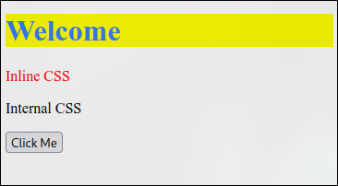

**Experiment 2 (b)**

**Aim:-** Introduction to JavaScript and its types

JavaScript is a **dynamic programming language** used for creating **interactive** web pages. It enhances **functionality**, handles **events**, and manipulates the **DOM**.

**Types of JavaScript**

1. **Internal JavaScript** (Written inside <script> tags in HTML)

<script>

alert("Hello, this is Internal JavaScript!");

</script>

* + **Pros:** Easy to use for small scripts.
  + **Cons:** Hard to maintain in large projects.

1. **External JavaScript** (Written in a separate .js file and linked to HTML)

<script src="script.js"></script>

console.log("This is External JavaScript.");

* + **Pros:** Reusable and maintainable.
  + **Cons:** Requires an extra file.

1. **Inline JavaScript** (Used directly inside HTML elements)

<button onclick="alert('Inline JavaScript!')">Click Me</button>

* + **Pros:** Quick for simple actions.
  + **Cons:** Hard to debug and maintain.

### Eg.

HTML (index.html)

<!DOCTYPE html>

<html>

<head><title>JS Example</title></head>

<body>

<button onclick="alert('Hello, JavaScript!')">Click Me</button>

<script>console.log("Script Loaded!");</script>

</body>

</html>

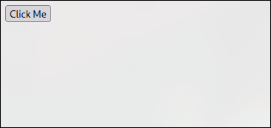

**Experiment 3 (a)**

**Aim:-** To create a time-table using HTML

Code:-

<!DOCTYPE html>

<html lang="en">

<head>

<meta charset="UTF-8">

<meta name="viewport" content="width=device-width, initial-scale=1.0">

<title>College Timetable</title>

<style>

table {

width: 100%;

border-collapse: collapse;

}

th, td {

border: 1px solid black;

text-align: center;

padding: 8px;

}

th {

background-color: #f2f2f2;

}

</style>

</head>

<body>

<h1>3rd Year, IT3</h1>

<table>

<tr>

<th>Time</th>

<th>08:00-09:00</th>

<th>09:00-10:00</th>

<th>10:00-11:00</th>

<th>11:00-12:00</th>

<th>BREAK</th>

<th>12:30-01:30</th>

<th>01:30-02:30</th>

<th>02:30-03:30</th>

<th>03:30-04:30</th>

<th>04:30-05:30</th>

</tr>

<tr>

<th>Monday</th>

<td>-x-</td>

<td>-x-</td>

<td>DBM_Th<br>Ms. Jasleen Kaur Bhatia<br>Lect_33</td>

<td>PME_Th<br>Dr. Mandeep Kaur<br>Lect_33</td>

<td>-X-</td>

<td>Adv_Java_Th<br>Dr. Amandeep Kaur<br>Lect_34</td>

<td>UHV-1_Th<br>Ms. Deepinder Kaur (Eng)<br>Lect_34</td>

<td>AI_Th<br>Ms. Shikha<br>Lect_34</td>

<td>IOT_Th<br>Ms. Upasana<br>Lect_34</td>

<td>-x-</td>

</tr>

<tr>

<th>Tuesday</th>

<td>-x-</td>

<td>-x-</td>

<td>3rd Year, IT3_B<br>AI_I_Lab<br>Ms. Shikha<br>LAB_14</td>

<td>3rd Year, IT3_B<br>AI_I_Lab<br>Ms. Shikha<br>LAB_14</td>

<td>-X-</td>

<td>DBM_Th<br>Ms. Jasleen Kaur Bhatia<br>Lect_34</td>

<td>PME_Th<br>Dr. Mandeep Kaur<br>Lect_34</td>

<td>AI_Th<br>Ms. Shikha<br>Lect_33</td>

<td>Web_D_Th<br>Ms. Kritika<br>Lect_34</td>

<td>-x-</td>

</tr>

<tr>

<th>Wednesday</th>

<td>-x-</td>

<td>-x-</td>

<td>Web_D_Th<br>Ms. Kritika<br>Lect_34</td>

<td>PME_Th<br>Dr. Mandeep Kaur<br>Lect_34</td>

<td>-X-</td>

<td>3rd Year, IT3_A<br>AI_I_Lab<br>Ms. Shikha<br>LAB_14</td>

<td>3rd Year, IT3_B<br>Web_D_I_Lab<br>Ms. Kritika<br>LAB_12</td>

<td>3rd Year, IT3_B<br>Web_D_I_Lab<br>Ms. Kritika<br>LAB_12</td>

<td>IOT_Th<br>Ms. Upasana<br>Lect_34</td>

<td>-x-</td>

</tr>

<tr>

<th>Thursday</th>

<td>-x-</td>

<td>-x-</td>

<td>3rd Year, IT3_A<br>IOT_Lab<br>Ms. Shipra Raheja<br>LAB_11</td>

<td>3rd Year, IT3_B<br>Adv_Java_I_Lab<br>Mr. Aman Kumar<br>LAB_13</td>

<td>-X-</td>

<td>3rd Year, IT3_A<br>IOT_Lab<br>Ms. Shipra Raheja<br>LAB_11</td>

<td>3rd Year, IT3_B<br>Adv_Java_I_Lab<br>Mr. Aman Kumar<br>LAB_13</td>

<td>DBM_Th<br>Ms. Jasleen Kaur Bhatia<br>Lect_33</td>

<td>AI_Th<br>Ms. Shikha<br>Lect_34</td>

<td>-x-</td>

</tr>

<tr>

<th>Friday</th>

<td>-x-</td>

<td>-x-</td>

<td>3rd Year, IT3_A<br>Web_D_I_Lab<br>Ms. Kritika<br>LAB_12</td>

<td>3rd Year, IT3_B<br>IOT_Lab<br>Ms. Shipra Raheja<br>LAB_11</td>

<td>-X-</td>

<td>3rd Year, IT3_A<br>Web_D_I_Lab<br>Ms. Kritika<br>LAB_12</td>

<td>3rd Year, IT3_B<br>IOT_Lab<br>Ms. Shipra Raheja<br>LAB_11</td>

<td>DBM_Th<br>Ms. Jasleen Kaur Bhatia<br>Lect_34</td>

<td>Adv_Java_Th<br>Dr. Amandeep Kaur<br>Lect_34</td>

<td>-x-</td>

</tr>

<tr>

<th>Saturday</th>

<td>-x-</td>

<td>-x-</td>

<td>-x-</td>

<td>-x-</td>

<td>-x-</td>

<td>-x-</td>

<td>-x-</td>

<td>-x-</td>

<td>-x-</td>

<td>-x-</td>

</tr>

</table>

</body>

</html>

Output:-

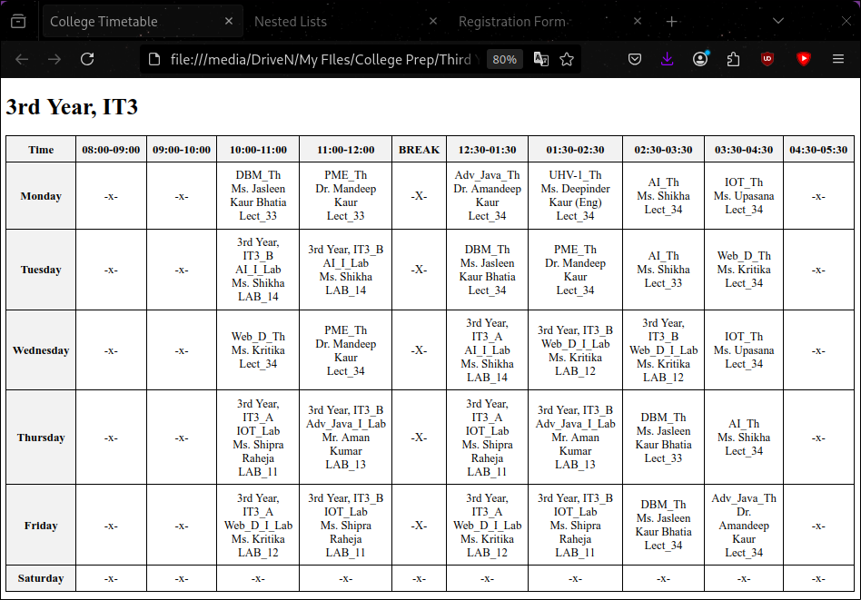

**Experiment 3 (b)**

Aim:- To create nested lists using HTML

Code:-

<!DOCTYPE html>

<html lang="en">

<head>

<meta charset="UTF-8">

<meta name="viewport" content="width=device-width, initial-scale=1.0">

<title>Nested Lists</title>

</head>

<body>

<h1>Nested Lists Example</h1>

<h2>Ordered List</h2>

<ol>

<li>Item 1

<ol>

<li>Subitem 1.1</li>

<li>Subitem 1.2</li>

</ol>

</li>

<li>Item 2</li>

<li>Item 3</li>

</ol>

<h2>Unordered List</h2>

<ul>

<li>Item A

<ul>

<li>Subitem A.1</li>

<li>Subitem A.2</li>

</ul>

</li>

<li>Item B</li>

<li>Item C</li>

</ul>

<h2>Definition List</h2>

<dl>

<dt>Term 1</dt>

<dd>Definition 1

<dl>

<dt>Subterm 1.1</dt>

<dd>Subdefinition 1.1</dd>

</dl>

</dd>

<dt>Term 2</dt>

<dd>Definition 2</dd>

</dl>

</body>

</html>

Output:-

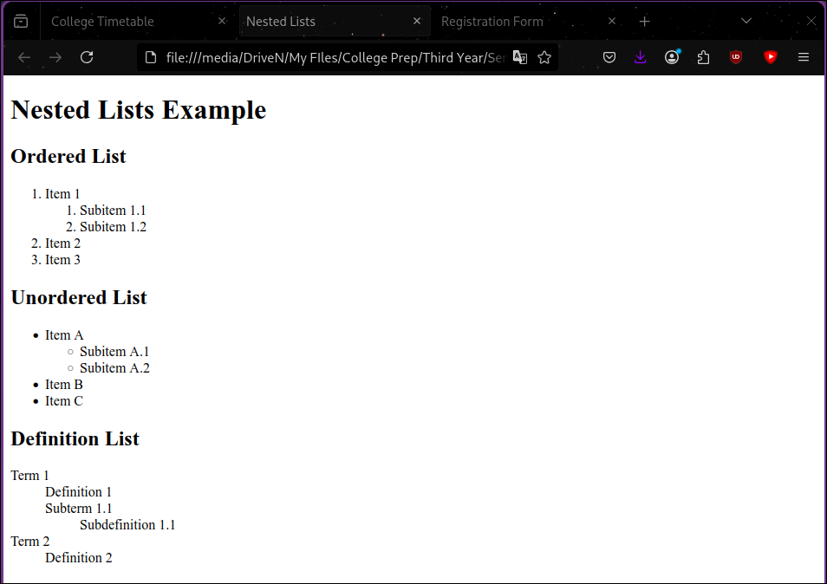

**Experiment 4 (a)**

Aim:- To create a registration form using HTML

Code:-

<!DOCTYPE html>

<html lang="en">

<head>

<meta charset="UTF-8">

<meta name="viewport" content="width=device-width, initial-scale=1.0">

<title>Registration Form</title>

</head>

<body>

<h2>Registration Form</h2>

<form action="/submit_registration" method="post">

<label for="fname">First Name:</label>

<input type="text" id="fname" name="fname" required><br><br>

<label for="lname">Last Name:</label>

<input type="text" id="lname" name="lname" required><br><br>

<label for="email">Email:</label>

<input type="email" id="email" name="email" required><br><br>

<label for="password">Password:</label>

<input type="password" id="password" name="password" required><br><br>

<label for="gender">Gender:</label>

<input type="radio" id="male" name="gender" value="male">

<label for="male">Male</label>

<input type="radio" id="female" name="gender" value="female">

<label for="female">Female</label><br><br>

<label for="country">Country:</label>

<select id="country" name="country">

<option value="india">I</option>

<option value="canada">Canada</option>

<option value="uk">UK</option>

<option value="australia">Australia</option>

</select><br><br>

<input type="submit" value="Register">

</form>

</body>

</html>

Output:-

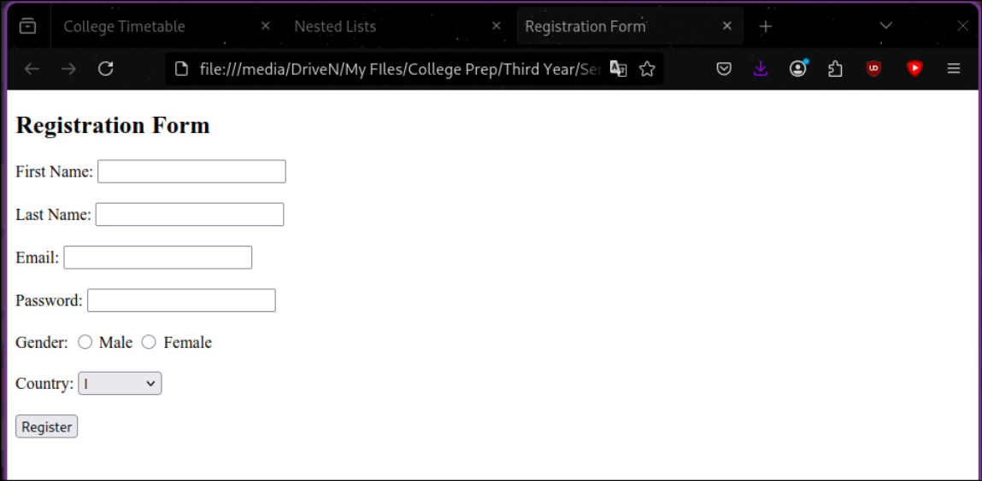

**Experiment 4 (b)**

**Aim:-** To create frames and hyperlinks using HTML

Code:-

<!DOCTYPE html>

<html lang="en">

<head>

<meta charset="UTF-8">

<meta name="viewport" content="width=device-width, initial-scale=1.0">

<title>Embed Websites using Iframes</title>

</head>

<body>

<h2>Embedded Websites</h2>

<iframe src="https://www.example.com" width="600" height="400" title="Example Website"></iframe>

<iframe src="https://www.wikipedia.org" width="600" height="400" title="Wikipedia"></iframe>

<h2>Links</h2>

<ul>

<li><a href="https://www.example.com" target="_blank">Example Website</a></li>

<li><a href="https://www.wikipedia.org" target="_blank">Wikipedia</a></li>

</ul>

</body>

</html>

Output:-

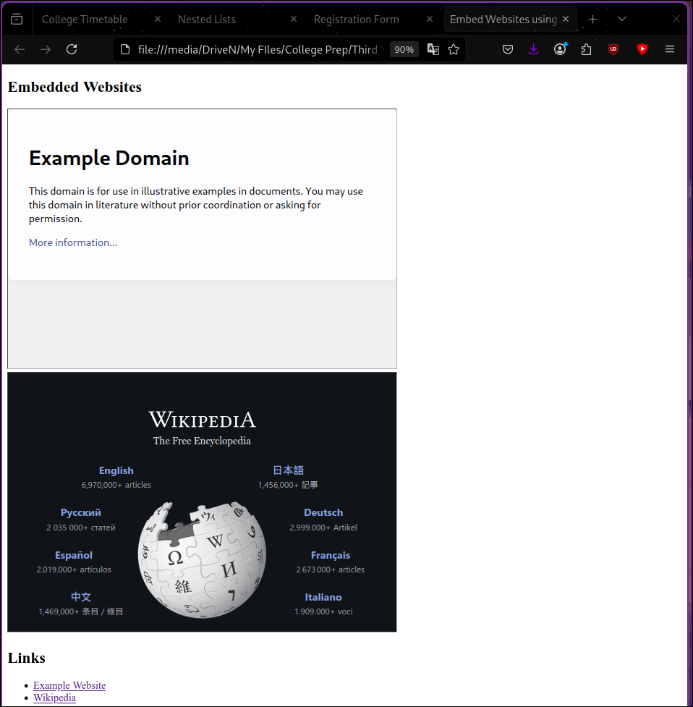

**Experiment 5 (a)**

**Aim:-** Create a static website using HTML, CSS, and JavaScript

Code:-

<!DOCTYPE html>

<html lang="en">

<head>

<meta charset="UTF-8">

<meta name="viewport" content="width=device-width, initial-scale=1.0">

<title>Static Webpage</title>

<style>

body {

font-family: Arial, sans-serif;

margin: 0;

padding: 0;

}

header {

background-color: #4CAF50;

color: white;

text-align: center;

padding: 1em 0;

}

nav {

display: flex;

justify-content: center;

background-color: #333;

}

nav a {

color: white;

padding: 14px 20px;

text-decoration: none;

text-align: center;

}

nav a:hover {

background-color: #ddd;

color: black;

}

.content {

padding: 20px;

text-align: center;

}

.content img {

max-width: 100%;

height: auto;

}

.form-container {

max-width: 600px;

margin: 0 auto;

padding: 20px;

border: 1px solid #ccc;

border-radius: 5px;

}

footer {

background-color: #333;

color: white;

text-align: center;

padding: 1em 0;

position: fixed;

width: 100%;

bottom: 0;

}

img {

width: 25%;

height: 25%;

}

</style>

</head>

<body>

<header>

<h1>Welcome to My Static Webpage</h1>

</header>

<nav>

<a href="#home">Home</a>

<a href="#about">About</a>

<a href="#services">Services</a>

<a href="#contact">Contact</a>

</nav>

<div class="content">

<h2>About Us</h2>

<img src="https://www.researchgate.net/publication/288825767/figure/fig1/AS:650042314596387@1531993573969/The-image-of-the-Montmorency-forest-airborne-C-X-SAR-580-image-7-looks-800x400-pixel.png" alt="Sample Image">

<div class="form-container">

<h2>Query Form</h2>

<form>

<label for="name">Name:</label><br>

<input type="text" id="name" name="name"><br><br>

<label for="email">Email:</label><br>

<input type="email" id="email" name="email"><br><br>

<label for="message">Message:</label><br>

<textarea id="message" name="message" rows="2" cols="50"></textarea><br><br>

<input type="submit" value="Submit">

</form>

</div>

</div>

<footer>

<p>&copy; 2025 My Static Webpage</p>

</footer>

</body>

</html>

Output:-

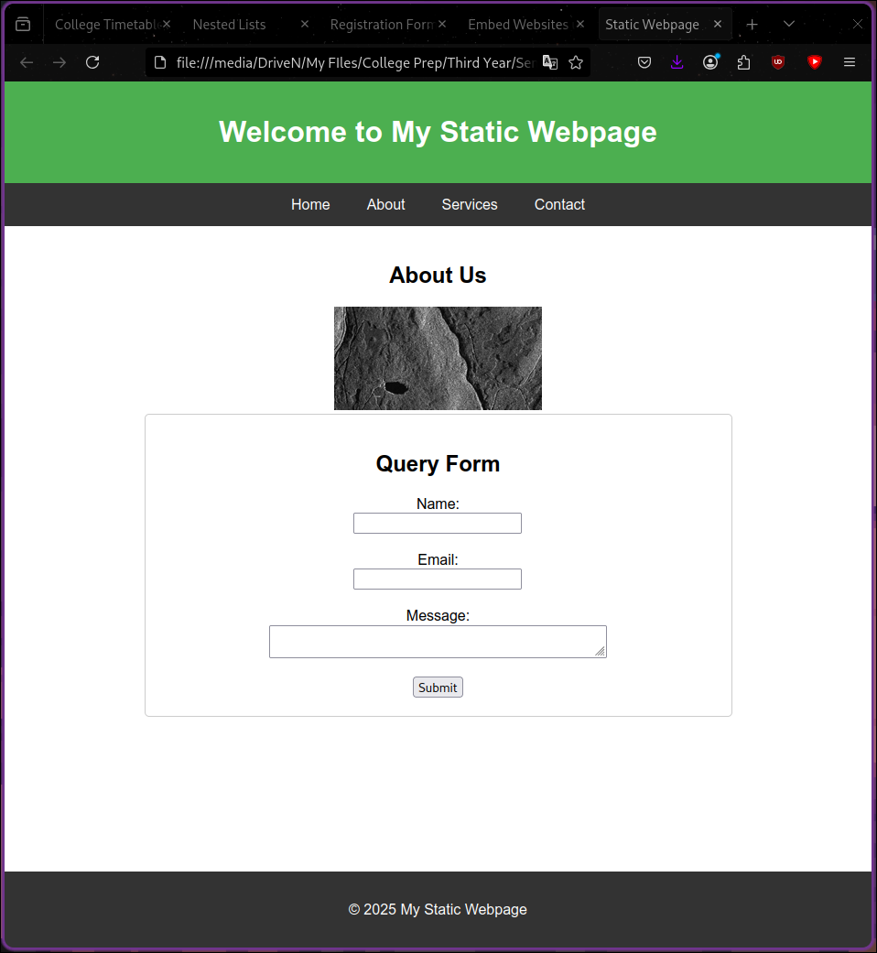

**Experiment 5 (b)**

**Aim:-** Install and set up Node.JS and Express.JS

### ****Step 1: Install Node.js and npm****

1. Open a terminal and update the package database:

sudo pacman -Syu

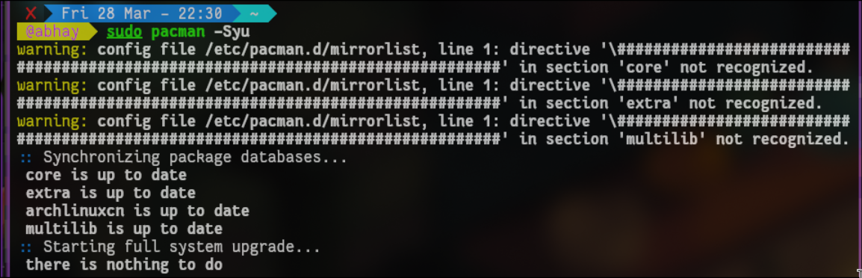

1. Install Node.js and npm:

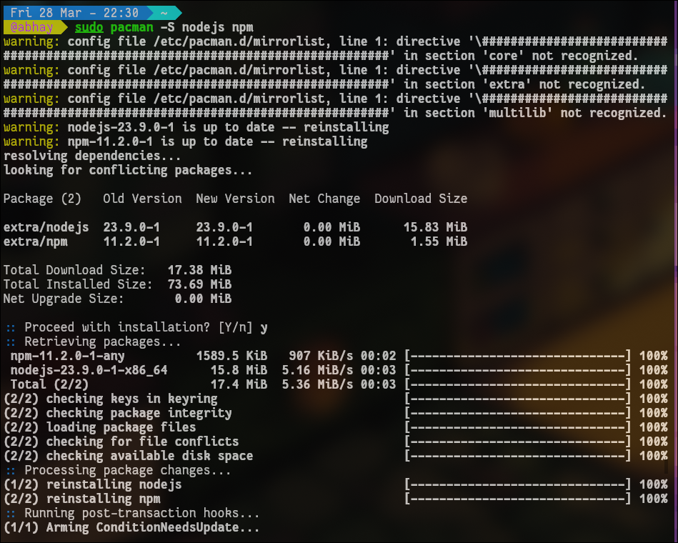sudo pacman -S nodejs npm

1. Verify the installation:

node -v

npm -v

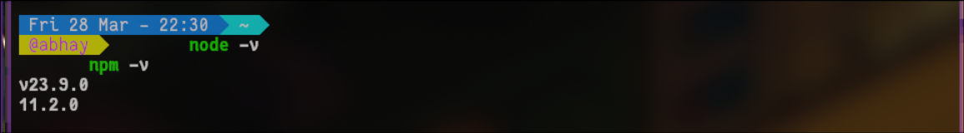

If both commands return version numbers, Node.js and npm are installed successfully.

### ****Step 2: Set Up an Express.js Project****

1. Create a new project folder:

mkdir my-express-app && cd my-express-app



1. Initialize a Node.js project:

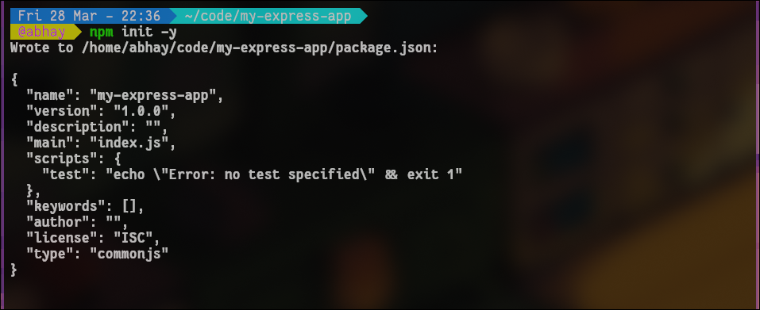npm init -y

This generates a package.json file.

1. Install Express.js:

npm install express

### 

### ****Step 3: Create an Express.js Server****

1. Create an index.js file:

touch index.js

1. Open it in a text editor (e.g., nano):

nano index.js

Add the following code:

const express = require('express');

const app = express();

const port = 3002;

app.get('/', (req, res) => {

res.send('Hello, Express!');

});

app.listen(port, () => {

console.log(`Server running at http://localhost:${port}`);

});

Save and exit (Ctrl + X, then Y, then Enter).

### ****Step 4: Run the Server****

Start the Express server:

node index.js

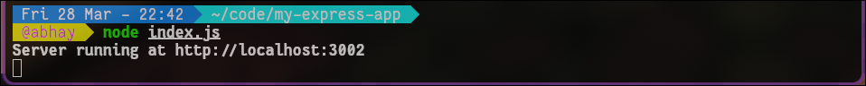

Now, open a browser and go to:

[http://localhost:3000](http://localhost:3000/)

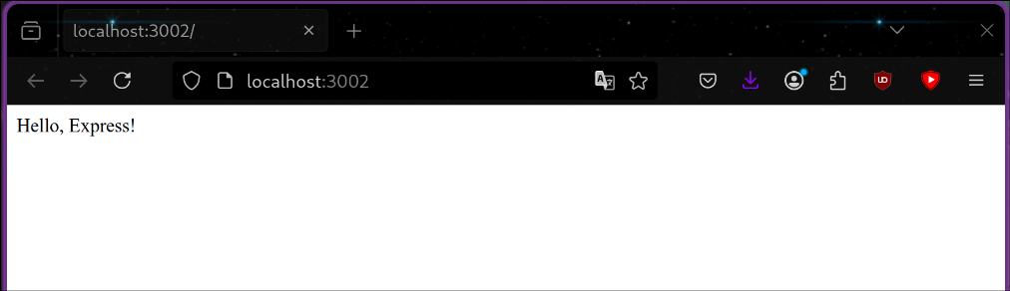

You should see **"Hello, Express!"**.

**Experiment 6**

**Aim:-** Set up React App and print “Hello World”

### ****Step 1: Install Node.js and npm****

(If not installed yet, follow these steps)

1. Open a terminal and update packages:

sudo pacman -Syu



1. Install Node.js and npm:

sudo pacman -S nodejs npm

1. Verify the installation:

node -v

npm -v



### ****Step 2: Create a React App****

1. Create a new React app:

npx create-react-app my-react-app

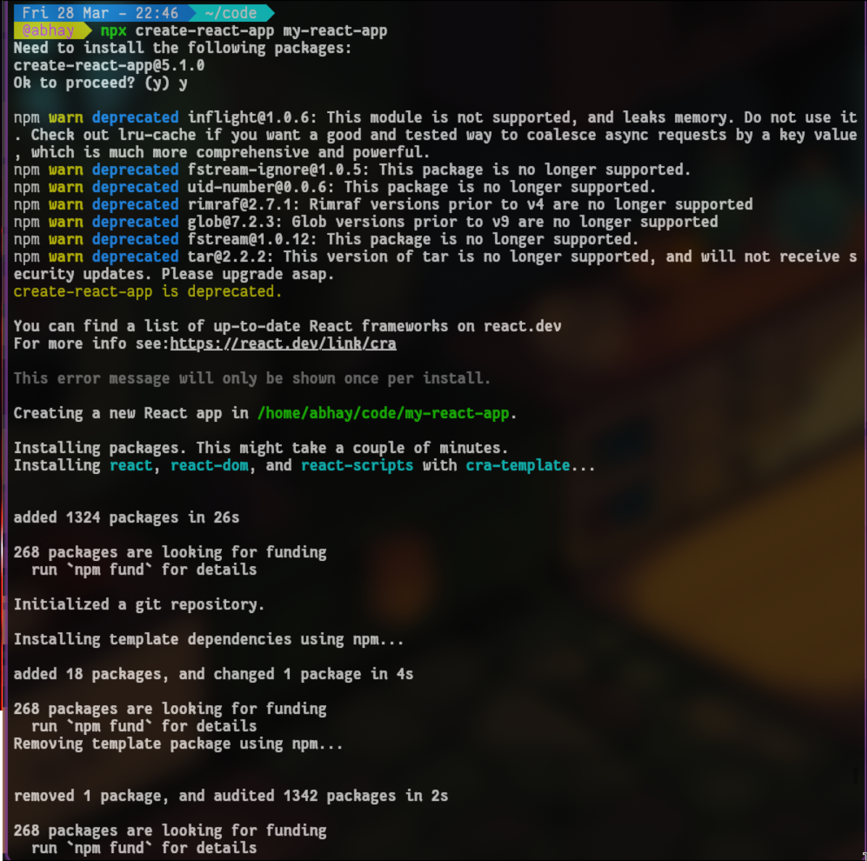

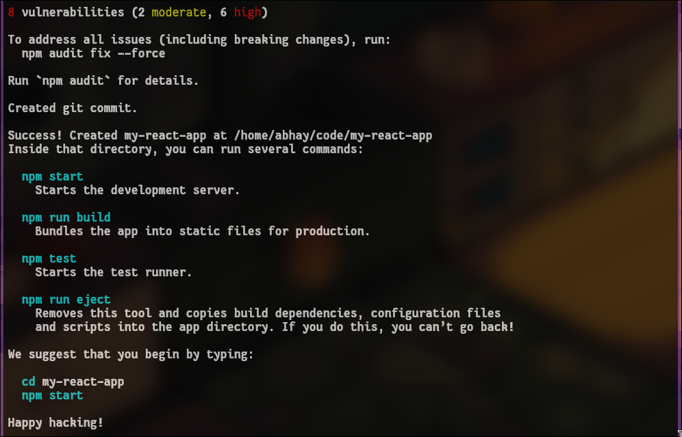

1. Move into the project folder:

cd my-react-app

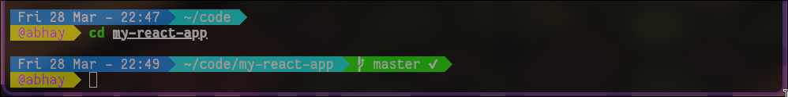

### ****Step 3: Modify React App to Print "Hello World"****

1. Open the file src/App.js in a text editor:

nano src/App.js

1. Replace its content with:

function App() {

return (

<div>

<h1>Hello World</h1>

</div>

);

}

export default App;

1. Save and exit (Ctrl + X, then Y, then Enter).

### ****Step 4: Start the React App****

Run the development server:

npm start

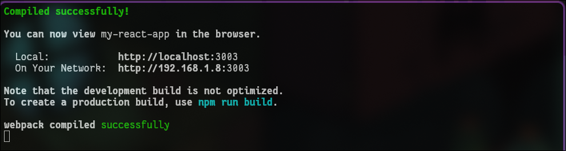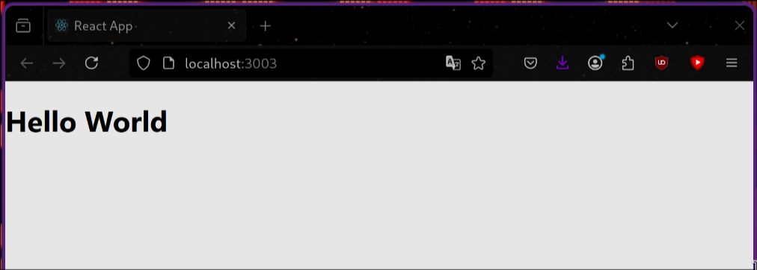

This will start the app on http://localhost:3000/, and you should see **"Hello World"** displayed on the page.

**Experiment 7**

**Aim:-** To make list components and table components

Code:-

/home/abhay/code/my-mui-app/src/App.js

import React from "react";

import ListComponent from "./ListComponent";

import TableComponent from "./TableComponent";

import { Container } from "@mui/material";

function App() {

return (

<Container sx={{ mt: 5 }}>

<ListComponent />

<TableComponent />

</Container>

);

}

export default App;

/home/abhay/code/my-mui-app/src/ListComponent.js

import React from "react";

import { Table, TableBody, TableCell, TableContainer, TableHead, TableRow, Paper, Typography } from "@mui/material";

const data = [

{ id: 1, name: "Alice", age: 25 },

{ id: 2, name: "Bob", age: 30 },

{ id: 3, name: "Charlie", age: 22 },

];

const TableComponent = () => {

return (

<TableContainer component={Paper} sx={{ maxWidth: 600, margin: "auto", mt: 5, boxShadow: 3 }}>

<Typography variant="h5" align="center" sx={{ mt: 2 }}>

Table Example

</Typography>

<Table>

<TableHead>

<TableRow>

<TableCell>ID</TableCell>

<TableCell>Name</TableCell>

<TableCell>Age</TableCell>

</TableRow>

</TableHead>

<TableBody>

{data.map((row) => (

<TableRow key={row.id}>

<TableCell>{row.id}</TableCell>

<TableCell>{row.name}</TableCell>

<TableCell>{row.age}</TableCell>

</TableRow>

))}

</TableBody>

</Table>

</TableContainer>

);

};

export default TableComponent;

/home/abhay/code/my-mui-app/src/ListComponent.js

import React from "react";

import { List, ListItem, ListItemText, Card, CardContent, Typography } from "@mui/material";

const items = ["Item 1", "Item 2", "Item 3", "Item 4"];

const ListComponent = () => {

return (

<Card sx={{ maxWidth: 400, margin: "auto", mt: 5, boxShadow: 3 }}>

<CardContent>

<Typography variant="h5" gutterBottom>

List Example

</Typography>

<List>

{items.map((item, index) => (

<ListItem key={index} divider>

<ListItemText primary={item} />

</ListItem>

))}

</List>

</CardContent>

</Card>

);

};

export default ListComponent;

Output:-

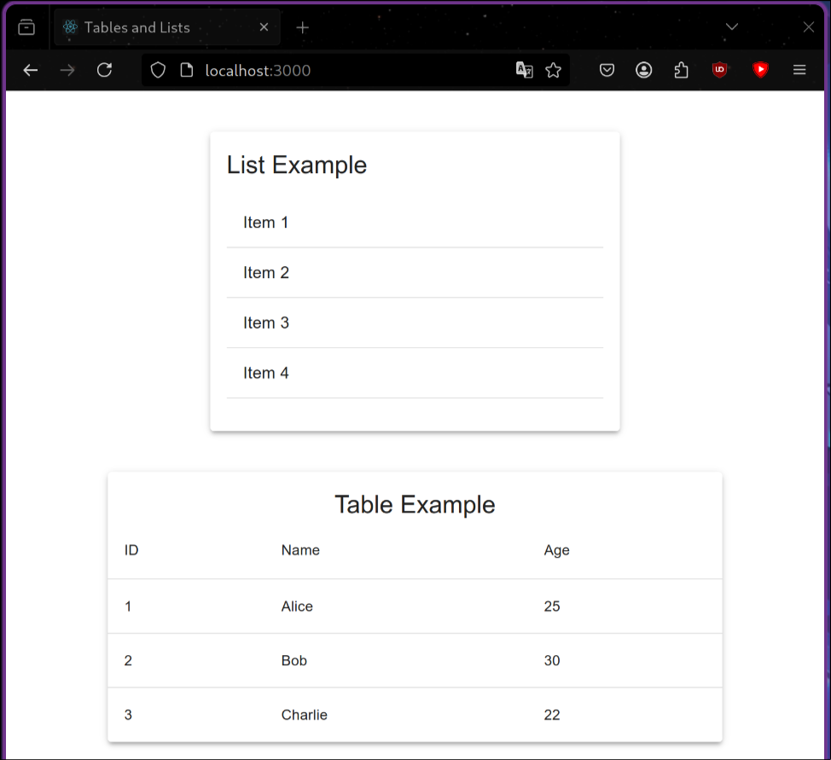

**Experiment 8 (a)**

**Aim:-** To perform use state in React to alter the state of components.

Code:-

/home/abhay/code/use-state-app/use-state-app/src/StateComponent.js

import React, { useState } from "react";

import { Button, Typography, Container, Card, CardContent } from "@mui/material";

const StateComponent = () => {

const [count, setCount] = useState(0);

return (

<Container sx={{ mt: 5 }}>

<Card sx={{ maxWidth: 400, margin: "auto", textAlign: "center", padding: 3,

border: "1px solid #E0E0E0", borderRadius: 2, backgroundColor: "white" // Light grey background

}}>

<CardContent>

<Typography variant="h5" gutterBottom>

Counter Example

</Typography>

<Typography variant="h6" color="primary">

Count: {count}

</Typography>

<Button variant="outlined" color="primary" sx={{ mt: 2 }} onClick={() => setCount(count + 1)}>

Increase Count

</Button>

</CardContent>

</Card>

</Container>

);

};

export default StateComponent;

/home/abhay/code/use-state-app/use-state-app/src/App.js

import React from "react";

import StateComponent from "./StateComponent";

import ListStateComponent from "./ListStateComponent";

import ToggleComponent from "./ToggleComponent";

import { Container } from "@mui/material";

function App() {

return (

<Container sx={{ mt: 5 }}>

<StateComponent />

</Container>

);

}

export default App;

Output:-

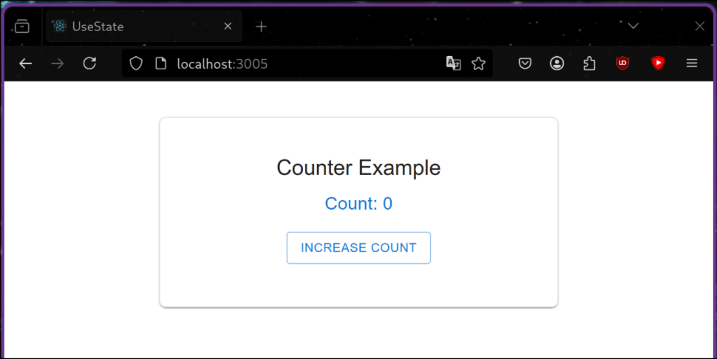

**Experiment 8 (b)**

**Aim:-** Use props to send data between components.

Code:-

/home/abhay/code/use-state-app/props-app/src/App.js

import React from "react";

import ParentComponent from "./ParentComponent";

import { Container } from "@mui/material";

function App() {

return (

<Container sx={{ mt: 5 }}>

<ParentComponent />

</Container>

);

}

export default App;

/home/abhay/code/use-state-app/props-app/src/ChildComponent.js

import React from "react";

import ChildComponent from "./ChildComponent";

import { Container, Typography } from "@mui/material";

const ParentComponent = () => {

return (

<Container sx={{ mt: 5, textAlign: "center" }}>

<Typography variant="h4" gutterBottom fontFamily={"sans-serif"}>

Parent Component

</Typography>

<ChildComponent message="Hello from Parent!" number={42} />

</Container>

);

};

export default ParentComponent;

/home/abhay/code/use-state-app/props-app/src/ParentComponent.js

import React from "react";

import { Card, CardContent, Typography } from "@mui/material";

const ChildComponent = ({ message, number }) => {

return (

<Card sx={{ maxWidth: 400, margin: "auto", mt: 3, boxShadow: 3,

borderRadius: 2,border:'1px solid', borderColor: "#f5f5f5", padding: 2, textAlign: "center"

}}>

<CardContent>

<Typography variant="h5" gutterBottom>

Child Component

</Typography>

<Typography variant="body1">Message: {message}</Typography>

<Typography variant="body1">Number: {number}</Typography>

</CardContent>

</Card>

);

};

export default ChildComponent;

Output:-

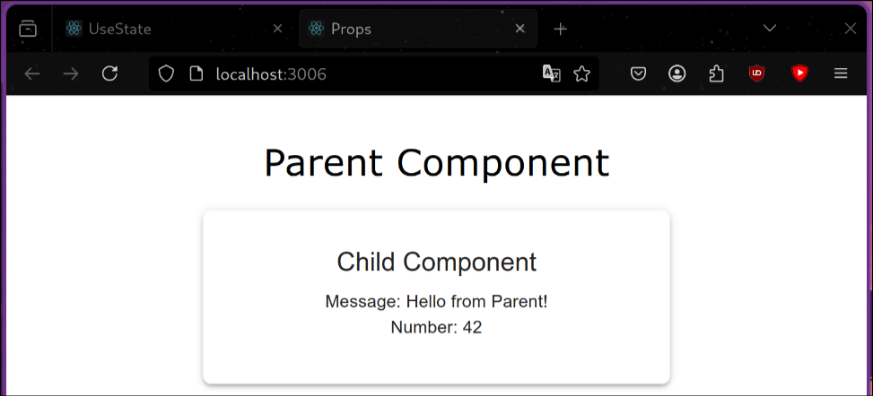

**Experiment 9**

**Aim:-** To create a server in Node.JS and Express.JS and send a get request.

Code:-

const express = require("express");

const app = express();

const PORT = 3011;

app.get("/data", (req, res) => {

res.json({ message: "Hello, this is JSON data!", status: "success" });

});

app.listen(PORT, () => {

console.log(`Server is running on http://localhost:${PORT}`);

});

Output:-

Postman:

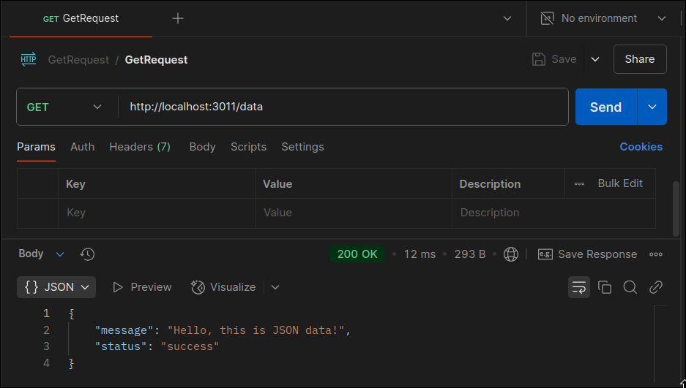

Browser:

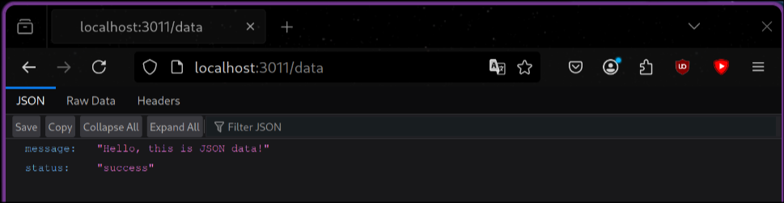

**Experiment 10 (a)**

**Aim:-** To install MongoDB Server and Mongosh on the local machine.

### ****Step 1: Install MongoDB****

MongoDB is available in the **Arch User Repository (AUR)**. You need an **AUR helper** like yay or paru to install it.

#### ****1.1 Install MongoDB Using**** yay

yay -S mongodb-bin

### 

### ****Step 2: Install MongoDB Shell (****mongosh****)****

To install MongoDB Shell:

yay -S mongosh-bin

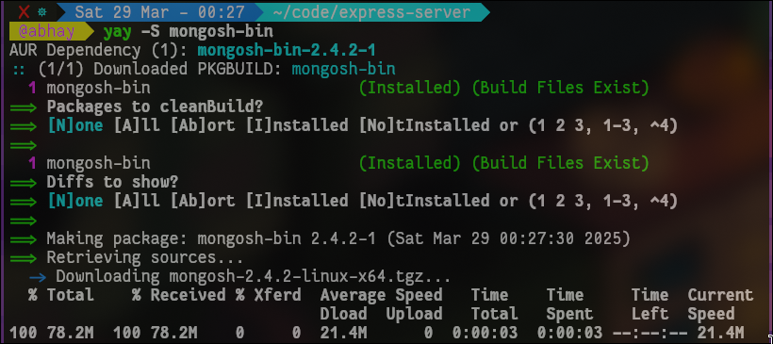

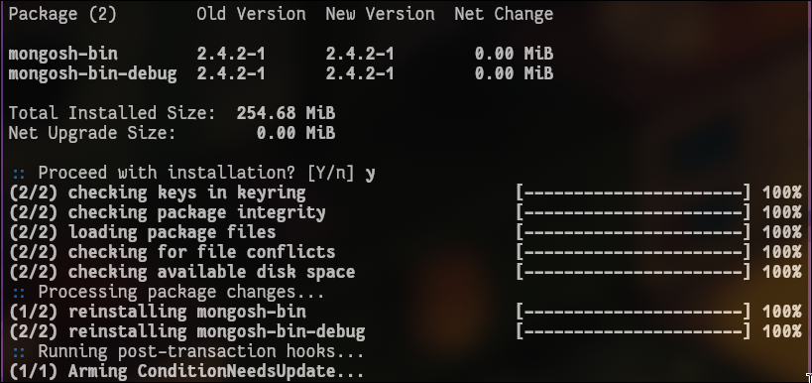

### ****Step 3: Start and Enable MongoDB Service****

After installation, start the MongoDB service:

sudo systemctl start mongodb

To enable it on startup:

sudo systemctl enable mongodb

Check if it’s running:

sudo systemctl status mongodb

If MongoDB is running, you should see:

Active: active (running)

### ****Step 4: Connect to MongoDB****

Now, open **MongoDB Shell (**mongosh**)** and connect:

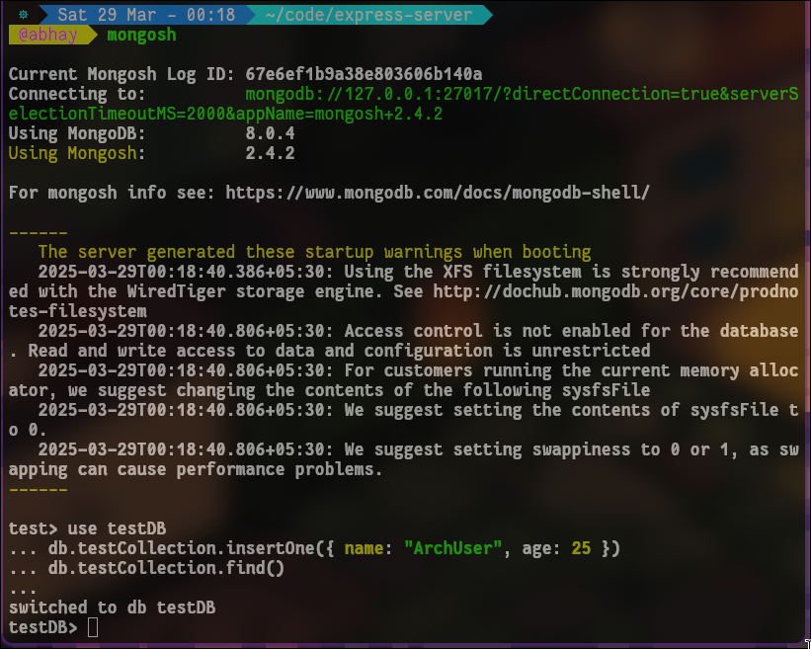mongosh

If connected successfully, you will see:

Current Mongosh Log ID: ...

Connecting to: mongodb://127.0.0.1:27017/

### ****Step 5: Create a Test Database****

Inside mongosh, run:

use testDB

db.testCollection.insertOne({ name: "ArchUser", age: 25 })

db.testCollection.find()

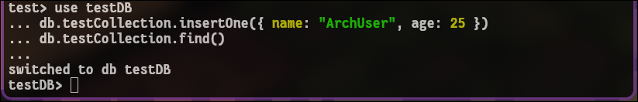

This inserts a test document into the testDB database and retrieves it.

### ****Step 6: Stop MongoDB (Optional)****

If you need to stop MongoDB:

sudo systemctl stop mongodb

To disable it from starting on boot:

sudo systemctl disable mongodb

**Experiment 10 (b)**

**Aim:-** Create a MongoDB and perform CRUD operations on it.

Code:-

const express = require("express");

const mongoose = require("mongoose");

const bodyParser = require("body-parser");

const cors = require("cors");

const app = express();

const PORT = 5000;

app.use(bodyParser.json());

app.use(cors());

mongoose.connect("mongodb://127.0.0.1:27017/mydatabase", {

useNewUrlParser: true,

useUnifiedTopology: true,

});

const db = mongoose.connection;

db.on("error", console.error.bind(console, "MongoDB connection error:"));

db.once("open", () => console.log("Connected to MongoDB"));

const ItemSchema = new mongoose.Schema({

name: String,

price: Number,

});

const Item = mongoose.model("Item", ItemSchema);

app.post("/items", async (req, res) => {

try {

const newItem = new Item(req.body);

await newItem.save();

res.status(201).json(newItem);

} catch (error) {

res.status(400).json({ error: error.message });

}

});

app.get("/items", async (req, res) => {

try {

const items = await Item.find();

res.json(items);

} catch (error) {

res.status(500).json({ error: error.message });

}

});

app.put("/items/:id", async (req, res) => {

try {

const updatedItem = await Item.findByIdAndUpdate(req.params.id, req.body, { new: true });

res.json(updatedItem);

} catch (error) {

res.status(400).json({ error: error.message });

}

});

app.delete("/items/:id", async (req, res) => {

try {

await Item.findByIdAndDelete(req.params.id);

res.json({ message: "Item deleted successfully" });

} catch (error) {

res.status(500).json({ error: error.message });

}

});

app.listen(PORT, () => {

console.log(`Server is running on http://localhost:${PORT}`);

});

Output:-

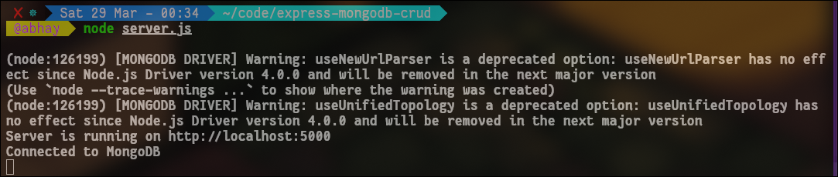

POST REQUEST:

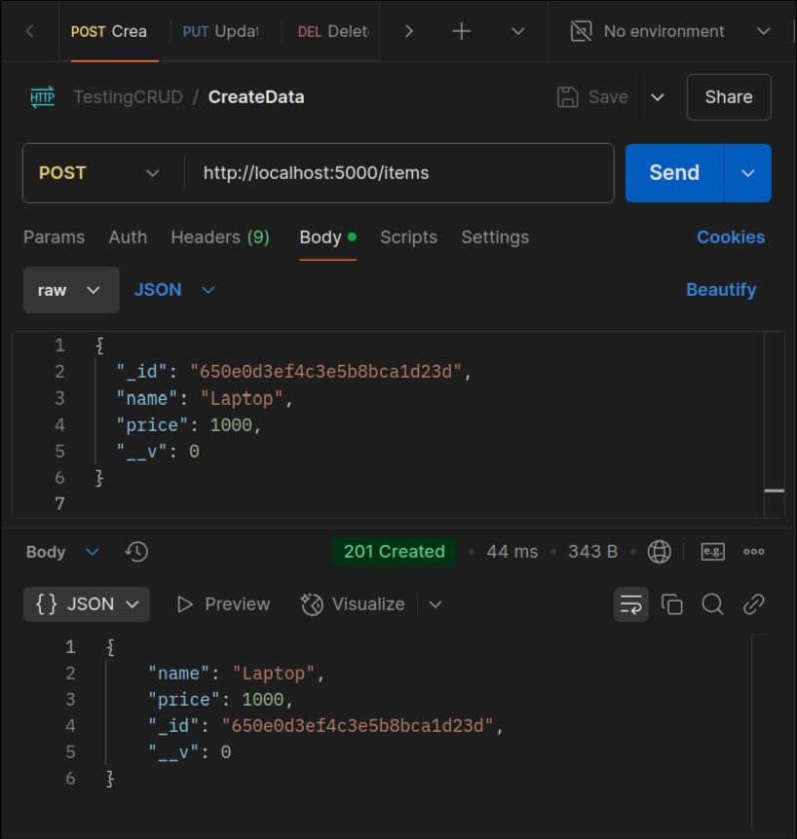

GET REQUEST:

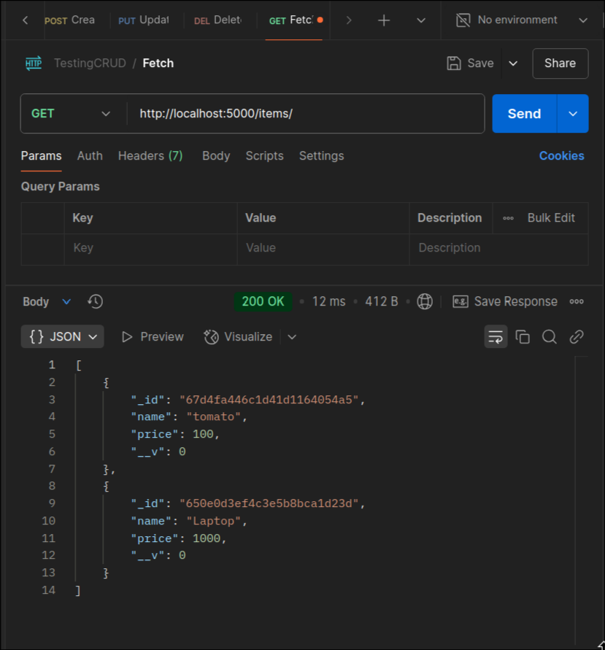

PUT REQUEST:

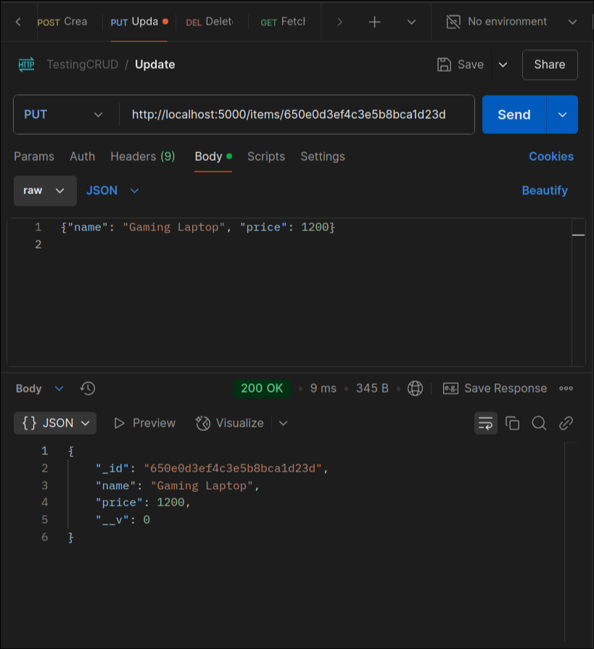

DELETE REQUEST:

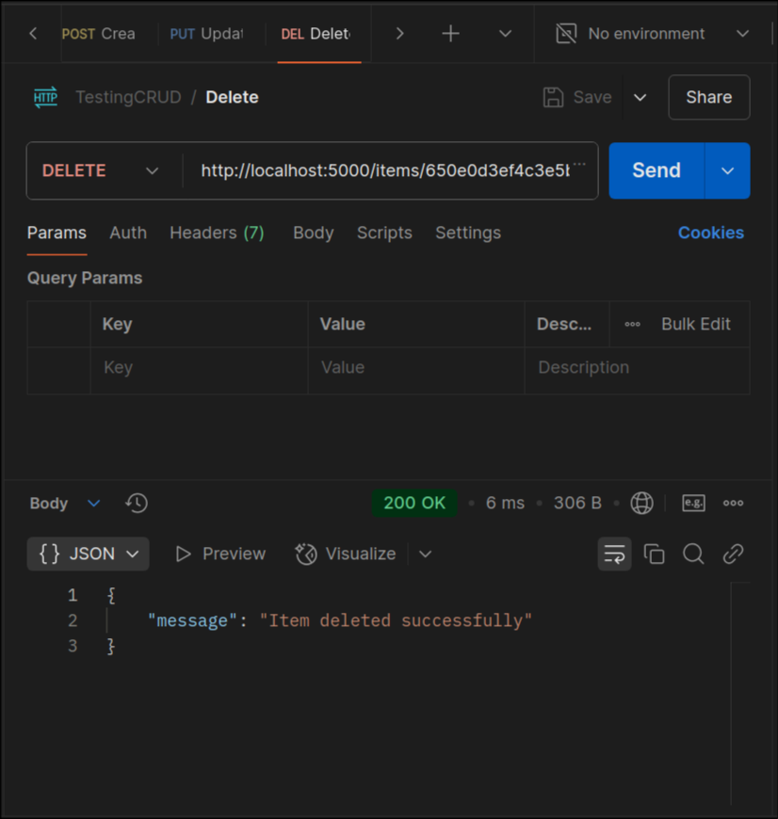

**Experiment 11**

**Aim:-** Task management tool: Login/Register to the application, add daily tasks, Assign a due date of completion, Mark them as complete/incomplete, and View weekly/monthly statistics of their to-dos.

Code:-

FRONTEND:

/home/abhay/WebstormProjects/task_management_tool/src/App.js

import { Routes, Route } from "react-router-dom";  
import React, {} from 'react';  
import SignUp from "./SignUp";  
import Home from "./Home";  
import CreateTask from "./CreateTask";  
import {  
 *Box*, *Divider*, *Link*,  
 *Typography*, *Grid*, *Grid2*} from "@mui/material";  
import {ThemeProvider, createTheme} from '@mui/material/styles';  
import CssBaseline from '@mui/material/CssBaseline';  
import Login from "./Login";  
import Dashboard from "./Dashboard";  
import ButtonAppBar from "./ButtonAppBar";  
import ProtectedRoute from "./ProtectedRoute";  
import *AuthContext*, {AuthProvider} from "./AuthContext";  
  
const darkTheme = createTheme({  
 palette: {  
 mode: 'light',  
 },  
});  
  
function App() {  
 //const { token } = useContext(AuthContext);  
 return (  
 <ThemeProvider theme={darkTheme}>  
 <CssBaseline/>  
 <React.Fragment>  
 <AuthProvider>  
 <ButtonAppBar/>  
 <Routes>  
 <Route path="/" element={<Home/>}/>  
 <Route path="/login" element={<Login/>}/>  
 <Route path="/signup" element={<SignUp/>}/>  
 <Route path="/createtask" element={<CreateTask/>}/>  
 <Route path="/dashboard" element={<Dashboard/>}/>  
 <Route element={<ProtectedRoute />}>  
 <Route path="/dashboard" element={<Dashboard />} />  
 </Route>  
 <Route path="*" element={<Login />} />  
 </Routes>  
 </AuthProvider>  
 <Footer/>  
 </React.Fragment>  
 </ThemeProvider>  
 );  
}  
  
function Footer() {  
 return (  
  
 <Box component="footer"  
 sx={{  
 backgroundColor: "#1976d2",  
 textAlign: "center",  
 fontFamily: "sans-serif",  
 fontSize: 25,  
 boxShadow: "0px -2px 10px rgba(0, 0, 0, 0.3)", // Darker shadow  
 zIndex: 1000, // Ensures it's above other elements  
 color: 'white',  
 bottom: 0,  
 width: "auto%",  
 minHeight: "200px",  
  
  
 }}>  
 <Grid2 sx={{  
 alignContent: "center",  
 alignItems: "center",  
  
 justifyContent: "center",  
 m: 1, p: 1  
  
 }} container spacing={2}>  
 <Grid2 sx={{  
 '--Grid-borderWidth': '1px',  
 borderRight: 'var(--Grid-borderWidth) solid',  
 borderColor: 'divider'  
 }} size={5}>  
 <Typography variant={"body1"} sx={{m: 1, p: 1}}>Tasks.Web.App  
 © {new *Date*().getFullYear()} Copyright </Typography>  
 <Typography variant={"body1"} sx={{m: 1, p: 1}}>Made by abhay-byte</Typography>  
 </Grid2>  
 <Grid2 size={5}>  
 <Typography variant={"body1"} sx={{m: 1, p: 1}}>  
 <Link href="/src/privacy-policy" color="inherit" underline="hover">  
 Privacy Policy  
 </Link>  
 </Typography>  
 <Typography variant={"body1"} sx={{m: 1, p: 1}}>  
 <Link href="/src/terms-conditons" color="inherit" underline="hover">  
 Terms and Conditions  
 </Link>  
 </Typography>  
  
 </Grid2>  
 </Grid2>  
  
  
 </Box>  
 );  
}  
export default App;

/home/abhay/WebstormProjects/task_management_tool/src/ButtonAppBar.js

import {useNavigate} from "react-router-dom";  
import {*AppBar*, *Box*, *IconButton*, *Toolbar*, *Typography*} from "@mui/material";  
import tmsicon from "./Images/tms1024.png";  
import React from "react";  
import Logout from "./Logout";  
  
export default function ButtonAppBar() {  
  
 let navigate = useNavigate();  
 const naviagteToHome = (e) => {  
 navigate("/");  
  
 }  
  
  
 return (  
 <Box sx={{flexGrow: 1}}>  
 <AppBar position="fixed">  
 <Toolbar>  
 <Typography variant="h6" component="div" sx={{flexGrow: 1, display:"flex", fontFamily: 'sans-serif', fontSize: 15, justifyContent: 'space-between'}}>  
 <Box sx={{flexGrow: 1}}>  
 <IconButton color="inherit" onClick={naviagteToHome}>  
 <img  
 srcSet={`${tmsicon}?w=164&h=164&fit=crop&auto=format&dpr=2 2x`}  
 src={`${tmsicon}?w=164&h=164&fit=crop&auto=format`}  
 alt={'Tms Icon'}  
 loading="lazy"  
 width="24"  
 height="24"  
 />  
 </IconButton>  
 Tasks.Web.App  
 </Box>  
  
 <Box alignContent={"right"}>  
 <Logout/>  
 </Box>  
  
 </Typography>  
 </Toolbar>  
 </AppBar>  
 </Box>  
 );  
}

/home/abhay/WebstormProjects/task_management_tool/src/Home.js

import {*motion*} from "motion/react";  
import {useNavigate} from "react-router-dom";  
import React, {useState, useEffect, useRef, useContext} from 'react';  
import *Button* from '@mui/material/Button';  
import {  
 *AppBar*,  
 *Box*, *ImageList*, *ImageListItem*,  
 *Typography*} from "@mui/material";  
import {ThemeProvider, createTheme} from '@mui/material/styles';  
import CssBaseline from '@mui/material/CssBaseline'  
import *AuthContext* from "./AuthContext";  
  
const darkTheme = createTheme({  
 palette: {  
 mode: 'light',  
 },  
});  
  
function Home() {  
 const {token} = useContext(*AuthContext*);  
 const itemData = [  
 {  
 img: 'https://storage.googleapis.com/profit-prod/wp-content/uploads/2022/07/d4eaf149-task-management.jpg',  
 title: 'Bed',  
 },  
 {  
 img: 'https://thumbs.dreamstime.com/z/business-task-management-vector-illustration-set-isolated-white-background-effective-corporate-time-tasks-planning-scheduling-157821557.jpg',  
 title: 'Books',  
 },  
 {  
 img: 'https://storage.googleapis.com/profit-prod/wp-content/uploads/2022/07/d4eaf149-task-management.jpg',  
 title: 'Bed',  
 },  
 {  
 img: 'https://www.cflowapps.com/wp-content/uploads/2018/07/task-management-process.png',  
 title: 'Sink',  
 },  
 {  
 img: 'https://www.ntaskmanager.com/wp-content/uploads/2021/02/Task-management-vs-project-management.jpg',  
 title: 'Kitchen',  
 },  
 {  
 img: 'https://storage.googleapis.com/profit-prod/wp-content/uploads/2022/07/d4eaf149-task-management.jpg',  
 title: 'Bed',  
 },  
 {  
 img: 'https://images.unsplash.com/photo-1588436706487-9d55d73a39e3',  
 title: 'Blinds',  
 },  
 {  
 img: 'https://www.cflowapps.com/wp-content/uploads/2018/07/task-management-process.png',  
 title: 'Storage',  
 },  
 {  
 img: 'https://wallpaperaccess.com/full/5137774.jpg',  
 title: 'Candle',  
 },  
 {  
 img: 'https://storage.googleapis.com/profit-prod/wp-content/uploads/2022/07/d4eaf149-task-management.jpg',  
 title: 'Bed',  
 },  
  
 ];  
 const navigate = useNavigate();  
 const navigateToSignUp = (e) => {  
 navigate("/signup");  
 }  
 const navigateToLogin = (e) => {  
 navigate("/login");  
 }  
 const navigateToDashboard = (e) => {  
 navigate("/dashboard");  
 }  
 return (  
 <ThemeProvider theme={darkTheme}>  
 <CssBaseline/>  
 <React.Fragment>  
 <motion.div initial={{scale: 0}} animate={{scale: 1}}>  
 <Box  
 sx={{  
 display: 'flex',  
 flexDirection: 'column',  
 justifyContent: 'space-between',  
 alignItems: 'center',  
 }}>  
 <Box component="section" sx={{  
 display: "flow",  
 justifyContent: "center",  
 alignItems: "center",  
 m: 1, p: 1,  
 width: 'auto%',  
 maxWidth: 800,  
 minWidth: 300,  
 textAlign: "center",  
 fontFamily: 'sans-serif',  
 }}>  
  
 <ImageList variant="masonry" cols={3} gap={8} sx={{mt: 10}}>  
 {itemData.map((item) => (  
 <ImageListItem key={item.img}>  
 <img  
 srcSet={`${item.img}?w=248&fit=crop&auto=format&dpr=2 2x`}  
 src={`${item.img}?w=248&fit=crop&auto=format`}  
 alt={item.title}  
 loading="lazy"  
 />  
 </ImageListItem>  
 ))}  
 </ImageList>  
  
 <Typography variant={'h4'} sx={{m: 3}}>Welcome to Tasks.Web.App</Typography>  
  
 <Typography variant={'body1'} sx={{m: 2}}>A place where you can create tasks, manage your  
 task and do it on time.</Typography>  
  
 <Typography variant={'body1'} sx={{m: 2}}>Sign up, if you are new or login to  
 use.</Typography>  
  
 {token &&  
 <Button variant={"outlined"} style={{margin: 10, marginBottom: 50, display: "inline"}}  
 onClick={navigateToDashboard}>Go To Dashboard</Button>}  
  
 {!token &&  
 <Button variant={"outlined"} style={{margin: 10, marginBottom: 50, display: "inline"}}  
 onClick={navigateToSignUp}>Register</Button>}  
  
 {!token &&  
 <Button variant={"outlined"} style={{margin: 10, marginBottom: 50, display: "inline"}}  
 onClick={navigateToLogin}>Login</Button>}  
  
  
 </Box>  
 </Box>  
  
 </motion.div>  
 </React.Fragment>  
 </ThemeProvider>  
 );  
}  
  
export default Home;

/home/abhay/WebstormProjects/task_management_tool/src/SignUp.js

import React, {useState} from "react";  
import {*motion*} from "motion/react";  
import {useNavigate} from "react-router-dom"  
import {  
 *Box*, Checkbox,  
 FormControlLabel, FormGroup,  
 TextField,  
 *Typography*} from "@mui/material";  
import {createTheme, ThemeProvider} from "@mui/material/styles";  
import CssBaseline from "@mui/material/CssBaseline";  
import *Button* from "@mui/material/Button";  
import ScrollToTop from "./ScrollToTop";  
import *axios* from "axios";  
const darkTheme = createTheme({  
 palette: {  
 mode: 'light',  
 },  
});  
  
function SignUp() {  
 ScrollToTop();  
 const label = {inputProps: {'aria-label': 'Checkbox demo'}};  
 const [showPassword, setShowPassword] = React.useState(false);  
 const navigate = useNavigate();  
 const handleClickShowPassword = () => setShowPassword((show) => !show);  
  
 const handleSignup = async (e) => {  
 e.preventDefault();  
 try {  
 const data = new *FormData*(e.currentTarget);  
 const username = data.get('username');  
 const password = data.get('password');  
 const email = data.get('email');  
 const res = await axios.post("http://localhost:5000/signup", { username, password ,email});  
 navigate("/login");  
 alert(res.data.message);  
 } catch (error) {  
 alert(error.response?.data?.message || "Signup failed");  
 }  
 };  
 const handleMouseDownPassword = (event) => {  
 event.preventDefault();  
 };  
  
 const handleMouseUpPassword = (event) => {  
 event.preventDefault();  
 };  
   
 const navigateToLogin = (e) => {  
 navigate("/login");  
 }  
 return (  
 <div>  
 <ThemeProvider theme={darkTheme}>  
 <CssBaseline/>  
 <React.Fragment>  
  
 <motion.div initial={{scale: 0}} animate={{scale: 1}} className="App">  
 <Box sx={{  
 alignItems: "center",  
 justifyContent: "center",  
 display: "flex",  
  
 }}>  
 <Box component="section" sx={{  
 display: "flex",  
 flexDirection: "column",  
 m: 4, p: 4,  
 borderRadius: 4,  
 boxShadow: 3,  
 maxWidth: 500,  
 minWidth: 300,  
 width: "auto%",  
 fontSize: 15,  
 mt: 10,  
 fontFamily: 'sans-serif',  
 textAlign: "center",  
  
  
 }}>  
 <Typography variant={'inherit'}>Sign Up</Typography>  
 <Box  
 component="form"  
 sx={{  
 '& .MuiTextField-root': {  
 m: 1, p: 1, width: '25ch',  
 display: "flex",  
  
 color: "grey",  
  
  
 }  
 }}  
 autoComplete="off"  
 onSubmit={handleSignup}>  
  
 <div style={{}}>  
 <img  
 src="https://static.vecteezy.com/system/resources/previews/003/689/228/original/online-registration-or-sign-up-login-for-account-on-smartphone-app-user-interface-with-secure-password-mobile-application-for-ui-web-banner-access-cartoon-people-illustration-vector.jpg"  
 alt="Description" width="300"/>  
 </div>  
 <TextField sx={{display: "inline-block"}} name="username" required label="Username"  
 variant="standard"  
 placeholder="Enter Username" id='username' margin="normal"></TextField>  
 <TextField sx={{display: "block"}} name="email" required label="Email"  
 variant="standard"  
 placeholder="Enter Email" id='email' margin="normal"></TextField>  
 <TextField sx={{display: "block"}}  
 name="password" required label="Password"  
 variant="standard" placeholder="Password" id='password'  
 type={showPassword ? 'text' : 'password'}  
  
 />  
 <TextField sx={{display: "block"}} name="confirm_password" required  
 label="Confirm Password"  
 variant="standard" placeholder="Re-Enter Password" id='confirm_password'  
 margin="normal" type={showPassword ? 'text' : 'password'}></TextField>  
  
 <FormGroup sx={{textAlign: 'left', fontSize: 16, color: 'grey', m: 1}}>  
 <FormControlLabel sx={{mt: 1}} required control={<Checkbox/>}  
 label="Agree to our Terms and Conditions."/>  
 <FormControlLabel sx={{mb: 1}} required control={<Checkbox/>}  
 label="Agree to our Privacy Policy."/>  
 </FormGroup>  
 <Button sx={{}} variant={"outlined"} type={"submit"}>Create Account</Button>  
  
 <Typography sx={{display: 'block', mt: 2}} variant={'overline'}>Already have an  
 account,  
 </Typography>  
 <Button sx={{fontSize: 12}} onClick={navigateToLogin}>Sign in here.</Button>  
  
 </Box>  
 </Box>  
 </Box>  
 </motion.div>  
 </React.Fragment>  
 </ThemeProvider>  
 </div>  
 );  
}  
  
export default SignUp;

/home/abhay/WebstormProjects/task_management_tool/src/Login.js

import React, {useContext, useState} from "react";  
import {useNavigate} from "react-router-dom";  
import { *motion* } from "motion/react";  
import {  
 *Box*, Checkbox,  
 FormControlLabel, FormGroup,  
 TextField,  
 *Typography*} from "@mui/material";  
import {createTheme, ThemeProvider} from "@mui/material/styles";  
import CssBaseline from "@mui/material/CssBaseline";  
import *Button* from "@mui/material/Button";  
import ScrollToTop from "./ScrollToTop";  
import *axios* from "axios";  
import *AuthContext* from "./AuthContext";  
const darkTheme = createTheme({  
 palette: {  
 mode: 'light',  
 },  
});  
  
  
function Login(){  
 ScrollToTop();  
 const navigate = useNavigate();  
 const label = { inputProps: { 'aria-label': 'Checkbox demo' } };  
 const [showPassword, setShowPassword] = React.useState(false);  
 const [username, setUsername] = useState("");  
 const [password, setPassword] = useState("");  
 const { login } = useContext(*AuthContext*);  
  
 const handleLogin = async (e) => {  
 e.preventDefault();  
 try {  
 const data = new *FormData*(e.currentTarget);  
 const username = data.get("username");  
 const password = data.get("password");  
  
 const res = await axios.post("http://localhost:5000/login", { username, password });  
 login(res.data.token);  
 navigate("/dashboard");  
 } catch (error) {  
 alert(error.response?.data?.message || "Login failed");  
 }  
 };  
 const handleClickShowPassword = () => setShowPassword((show) => !show);  
  
 const handleMouseDownPassword = (event) => {  
 event.preventDefault();  
 };  
  
 const handleMouseUpPassword = (event) => {  
 event.preventDefault();  
 };  
  
 const navigateToSignup= (e) => {  
 navigate("/signup");  
 }  
 return (  
 <div>  
 <ThemeProvider theme={darkTheme}>  
 <CssBaseline />  
 <React.Fragment>  
  
 <motion.div initial={{ scale: 0 }} animate={{ scale: 1 }} className="App">  
 <Box sx={{alignItems: "center",justifyContent: "center",display: "flex",alignContent: "center"}}>  
 <Box component="section" sx={{  
 display: "flex",  
 flexDirection: "column",  
 justifyContent: "center",  
 alignItems: "center",  
 m:4, p: 4,  
 borderRadius: 4,  
 boxShadow: 3,  
 maxWidth: 500,  
 minWidth: 300,  
 width: "auto%",  
 fontSize: 15,  
 mt:10,  
 fontFamily: 'sans-serif',  
 textAlign: "center",  
  
 }}>  
  
 <Box  
 component="form"  
 sx={{ '& .MuiTextField-root': { m: 1, p: 1 , width: '25ch',  
 display: "flex" ,}}}  
 autoComplete="off"  
 onSubmit={handleLogin}  
 >  
  
 <Typography variant={'inherit'}>Login</Typography>  
 <div style={{display:"inline", alignContent:"right"}}>  
 <img src = "https://static.vecteezy.com/system/resources/previews/011/432/528/original/enter-login-and-password-registration-page-on-screen-sign-in-to-your-account-creative-metaphor-login-page-mobile-app-with-user-page-flat-illustration-vector.jpg"  
 alt="Description" width="250" />  
 </div>  
 <TextField sx={{display:"inline"}} name="username" required label="Username" variant="standard" placeholder="Enter Username" id = 'username' margin = "normal"></TextField>  
 <TextField sx={{display:"block"}} name="password" required label="Password" variant="standard" placeholder="Enter Password" id = 'password' margin = "normal"  
 type={showPassword ? 'text' : 'password' } ></TextField>  
 <FormGroup sx={{textAlign: 'left', fontSize: 16, color: 'grey', m: 1}}>  
 <FormControlLabel sx={{mt: 1}} control={<Checkbox/>}  
 label="Stay Logged in for the session."/>  
 </FormGroup>  
  
 <Button sx={{mt:4}} variant={"outlined"} type={"submit"}>Login Account</Button>  
 <Typography sx={{display: 'block', mt: 2}} variant={'overline'}>Don't have an  
 account,  
 </Typography>  
 <Button sx={{fontSize: 12}} onClick={navigateToSignup}>Sign up here.</Button>  
 </Box>  
 </Box>  
 </Box>  
  
 </motion.div>  
 </React.Fragment>  
 </ThemeProvider>  
 </div>  
 );  
}  
  
export default Login;

/home/abhay/WebstormProjects/task_management_tool/src/Dashboard.js

import {useNavigate} from "react-router-dom";  
import * as React from 'react';  
import *Box* from '@mui/material/Box';  
import *IconButton* from '@mui/material/IconButton';  
import *Grid2* from '@mui/material/Grid';  
import *Typography* from '@mui/material/Typography';  
import {  
 *Backdrop*,  
 *Card*,  
 CardActions,  
 *CardContent*,  
 *Chip*,  
 *FormControl*, FormControlLabel,  
 *FormLabel*, Radio,  
 RadioGroup,  
 useMediaQuery  
} from "@mui/material";  
import *Button* from "@mui/material/Button";  
import *EditOutlinedIcon* from '@mui/icons-material/EditOutlined';  
import *DeleteOutlineOutlinedIcon* from '@mui/icons-material/DeleteOutlineOutlined';  
import {PieChart} from '@mui/x-charts/PieChart';  
import *AddBoxOutlinedIcon* from '@mui/icons-material/AddBoxOutlined';  
import {*motion*} from "motion/react";  
import ScrollToTop from "./ScrollToTop";  
import *AuthContext* from "./AuthContext";  
import {useContext, useEffect, useState} from "react";  
import *axios* from "axios";  
  
  
export default function Dashboard() {  
 ScrollToTop();  
 const months = ['Jan','February','March','April','May','June','July','August','September','October','November','December'];  
 const {user} = useContext(*AuthContext*);  
 const userId = user?.userId;  
 const navigate = useNavigate();  
 const [dense, setDense] = React.useState(false);  
 const [secondary, setSecondary] = React.useState(true);  
 const isMobile = useMediaQuery("(max-width:600px)"); // Mobile: Width ≤ 60  
 const [tasks, setTasks] = useState([]);  
 const [open, setOpen] = React.useState(false);  
 const handleClose = () => {  
 setOpen(false);  
 };  
 const [currentTask, setCurrentTask] = useState("");  
 const [currentTaskId, setCurrentTaskId] = useState("");  
  
 const handleOpen = (id, name) => {  
 setCurrentTaskId(id);  
 setCurrentTask(name);  
 setOpen(true);  
 };  
 useEffect(() => {  
 if(userId != null){  
 const params = new *URLSearchParams*([["userid",user["userId"]]]);  
 axios.get('http://localhost:5000/tasks',{ params: { userid: userId ,sort: 'asc'} })  
 .then((response) => {  
 setTasks(response.data);  
 })  
 .catch((error) => {  
 *console*.error('There was an error fetching the items!', error);  
 });  
 }  
  
 }, []);  
  
 const currentMonth = new *Date*().getMonth(); // Get current month (0-11)  
 const currentYear = new *Date*().getFullYear(); // Get current year  
  
 const filteredTasks = tasks.filter(task => {  
 const taskDate = new *Date*(task.startdate); // Convert startdate to Date  
 return taskDate.getMonth() === currentMonth && taskDate.getFullYear() === currentYear;  
 });  
  
 const taskCounts = filteredTasks.reduce(  
 (acc, task) => {  
 acc[task.status] = (acc[task.status] || 0) + 1;  
 return acc;  
 },  
 { completed: 0, pending: 0, due: 0 }  
 );  
  
 const taskItems = [  
 { id: 0, value: taskCounts.completed, label: "Completed", color: "blue" },  
 { id: 1, value: taskCounts.pending, label: "Pending", color: "#1976d2" },  
 { id: 2, value: taskCounts.due, label: "Due", color: "#E0E0E0" },  
 ];  
  
 const [status, setStatus] = useState("Ongoing");  
  
 const handleStatusChange = (event) => {  
 setStatus(event.target.value);  
 };  
  
 const updateTask = async () => {  
 try {  
 const response = await axios.put("http://localhost:5000/tasks", {  
 taskid: currentTaskId,  
 status  
 });  
 *console*.log("Task Updated:", response.data);  
 handleClose(); // Close modal after update  
 *window*.location.reload();  
 } catch (error) {  
 *console*.error("Error updating task:", error.response?.data || error.message);  
 }  
 };  
  
 const deleteTask = async (taskId) => {  
 try {  
 await axios.delete(`http://localhost:5000/tasks/${taskId}`); // Pass taskId in the URL  
 *console*.log("Task Deleted:", taskId);  
  
 *window*.location.reload(); // Refresh page after deletion  
 } catch (error) {  
 *console*.error("Error deleting task:", error.response?.data || error.message);  
 }  
 };  
  
 const navigateToCreateTask = () => {  
 navigate("/createTask");  
 };  
 return (  
 <Box sx={{  
 display: "flex", flexDirection: "Column", justifyContent: "space-between", mt: 10,  
 fontFamily: "sans-serif"  
 }}>  
  
 <motion.div initial={{scale: 0}} animate={{scale: 1}} style={{margin: 20}}>  
 <Box sx={{display: "flex", flexDirection: "column", justifyContent: "space-between"}}>  
  
 <Typography color={"grey"} variant={'body2'}> Welcome, </Typography>  
 <Box display="flex" alignItems="center" gap={2} justifyContent={"space-between"} >  
 <Typography p={1} align={"left"} variant={'h4'} gutterBottom>{user['username']}</Typography>  
  
 <Button onClick={navigateToCreateTask} variant="outlined" startIcon={<AddBoxOutlinedIcon />} sx={{ display: "flex", alignItems: "center" }}>  
 Create Task  
 </Button>  
 </Box>  
  
 <Box sx={{border:'1px solid',borderColor:'#E0E0E0', borderRadius:2, mt:3,mb:3, display: 'flex', flexDirection: isMobile?'column':'row', justifyContent: 'space-around'  
 ,minWidth:'80%'}}>  
  
 <Typography sx={{m:2}} >Statistics Of {months[new *Date*().getMonth()]}</Typography>  
 <PieChart sx={{p:2}}  
  
 series={[  
 {  
 data:taskItems,  
 innerRadius: 20,  
 outerRadius: isMobile ? 90 : 100,  
 paddingAngle: 5,  
 cornerRadius: 5,  
 startAngle: -45,  
 endAngle: 270,  
 cx: isMobile ? 120 : 150,  
 cy: isMobile ? 120 : 150,  
  
 },  
 ]}  
 labelPosition="outside"  
 width={isMobile ? 360 : 400}  
 height={isMobile ? 280 : 300}  
  
 />  
 <Box display={"flex"} flexDirection={'column'} justifyContent={'space-around'} alignItems={'center'} sx={{m:4, p:4}}>  
 <Typography color={"grey"} variant={"body1"}>Task completed: {taskItems[0].value}</Typography>  
 <Typography color={"grey"} variant={"body1"}>Task Ongoing: {taskItems[1].value}</Typography>  
 <Typography color={"grey"} variant={"body1"} gutterBottom={4}>Task Due: {taskItems[2].value}</Typography>  
 </Box>  
  
 </Box>  
  
 </Box>  
 <Typography variant="h4" gutterBottom>  
 Task List  
 </Typography>  
 <Grid2 container spacing={2}>  
 {tasks.map((task, index) => (  
 <Grid2 item xs={12} sm={6} md={4} key={index}>  
 <Card variant="outlined" sx={{ display: "block", flexDirection: "column", justifyContent: "space-between" }}>  
 <CardContent>  
 <Typography variant="body2" color="grey">Task Name</Typography>  
 <Typography variant="h6">{task.taskname}</Typography>  
 <Typography variant="body2" color="text.secondary">  
 Description: {task.taskdescription}  
 </Typography>  
  
 <Typography variant="body2" display="block">  
 <strong>Start:</strong> {task.startdate} | <strong>End:</strong> {task.enddate}  
 </Typography>  
  
 <Chip  
 variant="outlined"  
 label={task.status}  
 color={task.status === "completed" ? "success" : "warning"}  
 sx={{ marginTop: 1 }}  
 />  
  
 <CardActions>  
 <IconButton onClick={() => handleOpen(task.taskid, task.taskname)} color="primary" aria-label="edit">  
 <EditOutlinedIcon />  
 </IconButton>  
 <IconButton onClick={() => deleteTask(task.taskid)} color="error" aria-label="delete">  
 <DeleteOutlineOutlinedIcon />  
 </IconButton>  
 </CardActions>  
 </CardContent>  
 </Card>  
 </Grid2>  
 ))}  
 </Grid2>  
  
 {/* Backdrop for displaying selected task */}  
 <Backdrop sx={{alignContent:'center',direction:'flex',flexDirection: 'column', color: "#fff", zIndex: (theme) => theme.zIndex.drawer + 1 }} open={open} onClick={handleClose}>  
 <Card sx={{alignContent:'center',direction:'flex',flexDirection: 'column', padding: 2, backgroundColor: "white", borderRadius: 2 }} onClick={(e) => e.stopPropagation()}>  
 <Typography variant="h6" color="black">Task Name: {currentTask}</Typography>  
 <Typography variant="body2" color="text.secondary">Task ID: {currentTaskId}</Typography>  
  
 <FormControl margin="normal" sx={{alignContent:'center',direction:'flex',flexDirection: 'column'}}>  
 <FormLabel id="task-status-label">Task Status</FormLabel>  
 <RadioGroup  
 aria-labelledby="task-status-label"  
 value={status}  
 name="taskstatus"  
 onChange={handleStatusChange}  
 >  
 <FormControlLabel value="completed" control={<Radio />} label="Completed" />  
 <FormControlLabel value="pending" control={<Radio />} label="Pending" />  
 </RadioGroup>  
 </FormControl>  
  
 <Button variant="outlined" onClick={updateTask}>Update</Button>  
 </Card>  
 </Backdrop>  
  
 </motion.div>  
 </Box>  
 );  
};

/home/abhay/WebstormProjects/task_management_tool/src/CreateTask.js

import { BrowserRouter as Router, Routes, Route, Link, useNavigate } from "react-router-dom";  
import React, {useState, useEffect, useContext} from 'react';  
import *axios* from 'axios';  
import *Button* from '@mui/material/Button';  
import {  
 Alert, AlertTitle,  
 *Box*,  
 *FormControl*, FormControlLabel, *FormLabel*,  
 Radio, RadioGroup,  
 TextField,  
} from "@mui/material";  
import { ThemeProvider, createTheme } from '@mui/material/styles';  
import CssBaseline from '@mui/material/CssBaseline';  
import *AuthContext* from "./AuthContext";  
const darkTheme = createTheme({  
 palette: {  
 mode: 'light',  
 },  
});  
  
function App() {  
 const navigation = useNavigate();  
 const [tasks, setTasks] = useState([]);  
 const [formData, setFormData] = useState(new *FormData*());  
 const [responseMessage, setResponseMessage] = useState("");  
 const [alertContent, setAlertContent] = useState('');  
 const [s_alert, setSAlert] = useState(false);  
 const [e_alert, setEAlert] = useState(false);  
 const {user} = useContext(*AuthContext*);  
  
  
 const CreateNewTask = async (e) => {  
 e.preventDefault(); // Prevent page reload  
 let data = new *FormData*(e.currentTarget);  
  
 let taskdata = {  
 taskname: data.get('taskname'),  
 taskdescription: data.get('taskdescription'),  
 status: data.get('taskstatus'),  
 startdate: data.get('startdate'),  
 enddate: data.get('enddate'),  
 userid: user?.userId, // Ensure user object exists  
 };  
  
 try {  
 const response = await axios.post('http://localhost:5000/tasks', taskdata, {  
 headers: { "Content-Type": "application/json" },  
 });  
  
 setResponseMessage(response.data.message || "Success!");  
 setSAlert(true);  
 navigation("/dashboard");  
  
 } catch (error) {  
 setResponseMessage("Error submitting data");  
 setEAlert(true);  
 *console*.error("Error:", error);  
 }  
 };  
  
 return (  
  
 <ThemeProvider theme={darkTheme}>  
 <CssBaseline />  
 <React.Fragment>  
 {s_alert ? <Alert severity="success">  
 <AlertTitle>Success</AlertTitle>  
 Task Created Successfully!  
 </Alert>:<></>}  
 {e_alert ? <Alert severity="error">  
 <AlertTitle>Error</AlertTitle>  
 Task Not Created!  
 </Alert>:<></>}  
  
 <div className="App">  
 <Box component="section" sx={{  
 display: "flex",  
 justifyContent: "center",  
 alignItems: "center",  
 m:4, p: 4,  
 borderRadius: 4,  
 boxShadow: 5,  
 width: 'auto%',  
 mt:12}}>  
  
 <Box  
 component="form"  
 sx={{ '& .MuiTextField-root': { m: 1, p: 1 , width: '25ch' } }}  
 autoComplete="off"  
 onSubmit={CreateNewTask}  
 >  
 <h1 style={{ textAlign: "center" }}>Create Task</h1>  
 <TextField name="taskname" required label="Task Name" variant="outlined" placeholder="Enter Task" id = 'task' margin = "dense"></TextField>  
  
 <TextField required name="taskdescription" label="Task Desctiption" variant="outlined" placeholder="Enter Description" id = 'desc' margin = "dense"></TextField>  
 <br></br>  
 <TextField label="" name="startdate" type={"date"} variant="outlined" id = 's_date' margin = "dense" helperText={"Enter Start Date"}></TextField>  
  
 <TextField label="" name="enddate" type={"date"} variant="outlined" id = 's_date' margin = "dense" helperText={"Enter End Date"}></TextField>  
 <br></br>  
 <FormControl margin={"normal"}>  
 <FormLabel id="demo-radio-buttons-group-label">Task Status</FormLabel>  
 <RadioGroup  
 aria-labelledby="demo-radio-buttons-group-label"  
 defaultValue="Ongoing"  
 name="taskstatus"  
 >  
 <FormControlLabel value="completed" control={<Radio />} label="Completed" />  
 <FormControlLabel value="pending" control={<Radio />} label="Pending" />  
 </RadioGroup>  
 </FormControl>  
 <br></br>  
 <Button style={{  
 display: 'block',  
 margin: '10px auto',  
  
 }} variant={"outlined"} type={"submit"}>Add Task</Button>  
  
 </Box>  
 </Box>  
 </div>  
 </React.Fragment>  
 </ThemeProvider>  
 );  
}  
  
  
function Main() {  
 const navigate = useNavigate(); // Hook for navigation  
  
 return (  
 <div>  
 <h1>Welcome to App.js</h1>  
 <button onClick={() => navigate("/home")}>Go to Home</button>  
 </div>  
 );  
}  
  
export default App;

/home/abhay/WebstormProjects/task_management_tool/src/AuthContext.js

import { createContext, useState, useEffect } from "react";  
import { jwtDecode } from 'jwt-decode'  
  
const *AuthContext* = createContext(undefined);  
  
const GetUser = (token)=>{  
 try{  
 if (token) {  
 const user = jwtDecode(token);  
 return user;  
 }  
 }  
 catch(err){  
 *console*.log(err);  
 }  
  
};  
  
export const AuthProvider = ({ children }) => {  
 const [token, setToken] = useState(*localStorage*.getItem("token") || "");  
 const user = GetUser(token);  
  
 useEffect(() => {  
 *localStorage*.setItem("token", token);  
 *console*.log(user);  
 }, [token]);  
  
 const login = (newToken) => {  
 setToken(newToken);  
 };  
  
 const logout = () => {  
 setToken("");  
 *localStorage*.removeItem("token");  
 };  
  
 return (  
 <AuthContext.Provider value={{user, token, login, logout }}>  
 {children}  
 </AuthContext.Provider>  
 );  
};  
  
export default *AuthContext*;

BACKEND:

/home/abhay/WebstormProjects/tms_mongo_backend/server.js

import express from 'express';  
import mongoose from 'mongoose';  
import cors from 'cors';  
import *Tasks* from "./models/tasks.js";  
import *jwt* from 'jsonwebtoken';  
import bcrypt from "bcryptjs";  
import dotenv from "dotenv";  
import crypto from 'crypto';  
import 'dotenv/config'  
import *tasks* from "./models/tasks.js";  
  
const output = dotenv.config();  
*console*.log(output);  
const app = express();  
const PORT = 5000;  
  
// Middleware  
app.use(cors());  
app.use(express.*json*());  
  
const { JWT_SECRETS, MONGO_URI } = *process*.env;  
// MongoDB Connection  
mongoose.connect(MONGO_URI, {  
 useNewUrlParser: true,  
 useUnifiedTopology: true,  
});  
  
const userSchema = new mongoose.Schema({  
 username: { type: String, unique: true},  
 password: { type: String, required: true },  
 email: { type: String, unique: true, required: true },  
});  
  
const User = mongoose.model("User", userSchema);  
  
const db = mongoose.*connection*;  
db.on('error', (error) => *console*.error(error));  
db.once('open', () => *console*.log('Connected to MongoDB'));  
  
// Routes  
app.get('/', (req, res) => {  
 res.send('Hello from Express');  
});  
  
app.listen(PORT, () => {  
 *console*.log(`Server running on port ${PORT}`);  
});  
  
  
// Create Item  
app.post('/tasks', async (req, res) => {  
 const { taskname, taskdescription, startdate,enddate,status,userid } = req.body;  
  
 const taskid = crypto.randomUUID();  
 const task = new *Tasks*({  
 taskname,  
 taskdescription,  
 startdate,  
 enddate,  
 status,  
 userid,  
 taskid,  
 });  
  
 try {  
 const newtask = await task.save();  
 res.status(201).json(newtask);  
 } catch (err) {  
 res.status(400).json({ message: err.message });  
 }  
});  
  
// Get all Items  
app.get('/tasks', async (req, res) => {  
 try {  
 const id = req.query.userid;  
 const taskid = req.query.taskid;  
 const sortBy = req.query.sort ?? 'enddate';  
 const order = req.query.order === 'asc' ? 1 : -1;  
 const argument = {[`${sortBy}`]: order };  
 const taskStatus = req.query.status;  
 const limit = parseInt(req.query.limit);  
 const page = parseInt(req.query.page);  
  
 if (taskid)  
 {  
 const task = await *Tasks*.find({'taskid':taskid})  
 .exec();  
 res.json(task);  
 *console*.log(task);  
 }  
 else{  
 const task = await *Tasks*.find({'userid':id}).sort(argument)  
 .exec();  
 res.json(task);  
 *console*.log(task);  
 }  
  
 } catch (err) {  
 res.status(500).json({ message: err.message });  
 }  
});  
  
// Update Item  
app.put('/tasks', async (req, res) => {  
 const { status,taskid } = req.body;  
  
 try {  
 const updatedTask = await *Tasks*.findOneAndUpdate(  
 { taskid }, // Find by taskid, not _id  
 { status }, // Update only the status field  
 { new: true } // Return the updated document  
 );  
  
 if (!updatedTask) {  
 return res.status(404).json({ message: "Task not found" });  
 }  
  
 res.status(200).json(updatedTask);  
 } catch (error) {  
 res.status(400).json({ message: error.message });  
 }  
  
})  
  
//Delete item  
app.delete('/tasks/:id', async (req, res) => {  
 const taskid = req.params.id;  
 try {  
  
 await *Tasks*.findOneAndDelete(taskid);  
 res.status(200);  
 }  
 catch (error) {  
 res.status(400).json({ message: error.message });  
 }  
})  
  
// **Signup Route**  
app.post("/signup", async (req, res) => {  
 try {  
 const { username, password, email } = req.body;  
  
 const existingUser = await User.findOne({ username });  
 if (existingUser) return res.status(400).json({ message: "User already exists" });  
  
 const hashedPassword = await bcrypt.hash(password, 10);  
 const newUser = await User.create({ username, password: hashedPassword, email });  
  
 res.json({ message: "User registered successfully", user: newUser });  
 } catch (error) {  
 res.status(500).json({ message: "Error signing up", error });  
 }  
});  
  
// **Login Route**  
app.post("/login", async (req, res) => {  
 try {  
 const { username, password } = req.body;  
  
 const user = await User.findOne({ username });  
 if (!user) return res.status(401).json({ message: "Invalid credentials" });  
  
 const isMatch = await bcrypt.compare(password, user.password);  
 if (!isMatch) return res.status(401).json(  
 { message: "Invalid credentials" }  
 );  
  
 const token = *jwt*.sign({ userId: user._id, username }, JWT_SECRETS, { expiresIn: "1h" });  
 res.json({ token });  
 } catch (error) {  
 res.status(500).json({ message: "Error logging in", error });  
 }  
});  
  
const authenticate = (req, res, next) => {  
 const token = req.headers.authorization?.split(" ")[1];  
 if (!token) return res.status(401).json({ message: "Unauthorized" });  
  
 try {  
 const decoded = *jwt*.verify(token, JWT_SECRET);  
 req.user = decoded;  
 next();  
 } catch (error) {  
 res.status(401).json({ message: "Invalid token" });  
 }  
};  
  
// **Protected Route**  
app.get("/protected", authenticate, (req, res) => {  
 res.json({ message: "Access granted", user: req.user });  
});

/home/abhay/WebstormProjects/tms_mongo_backend/models/tasks.js

import mongoose, {Schema} from 'mongoose';  
  
const taskSchema = new Schema({  
 taskname: {  
 type: String,  
 required: true  
 },  
 taskdescription: {  
 type: String,  
 required: true  
 },  
 startdate: {  
 type: String,  
 required: true  
 },  
 enddate: {  
 type: String,  
 required: true  
 },  
 status: {  
 type: String,  
 enum: ['completed', 'pending', 'in-progress'], // Add possible statuses here  
 required: true  
 },  
 userid: {  
 type: String, // Reference to the User model  
 ref: 'User',  
 required: true  
 },  
 taskid: {  
 type: String,  
 }  
}, { timestamps: true }); // Automatically add createdAt and updatedAt fields  
  
  
export default mongoose.model('task', taskSchema);

Output:-

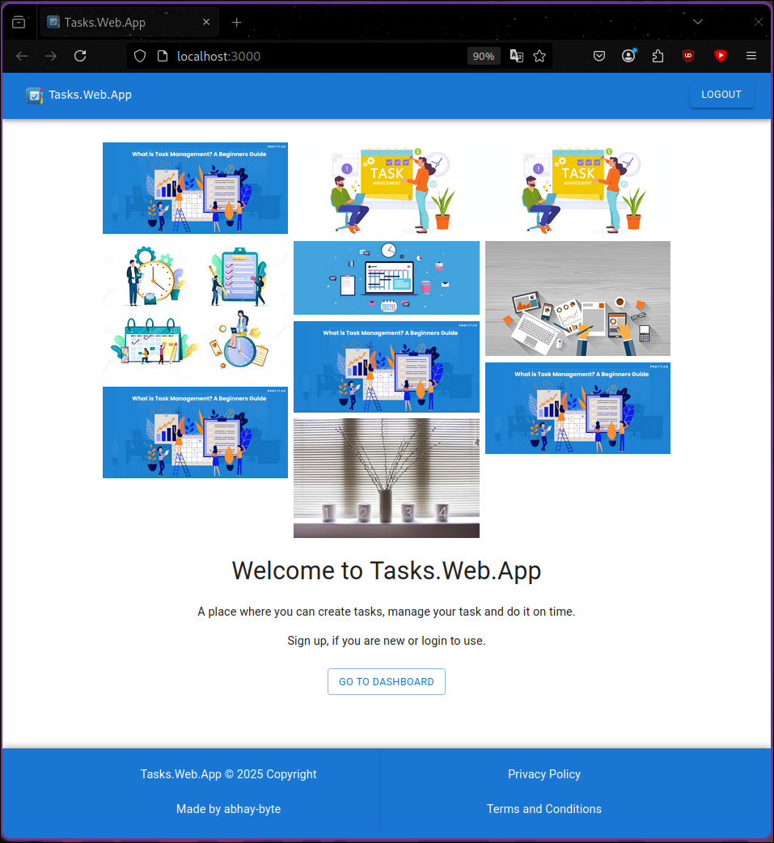

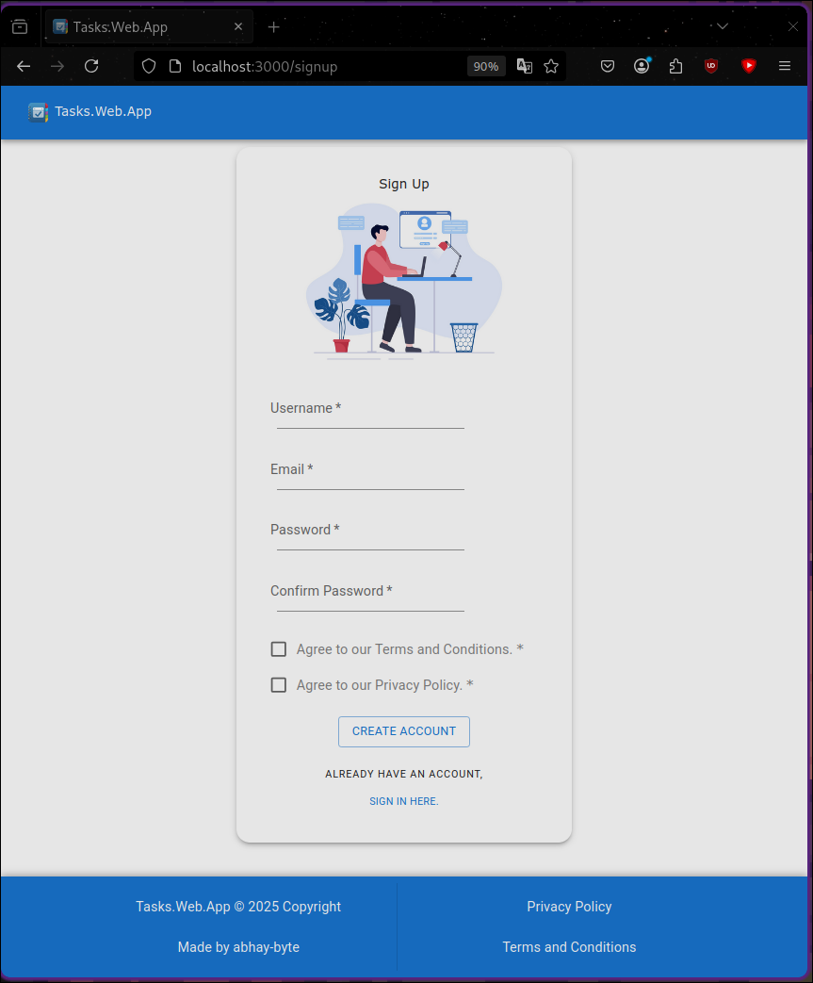

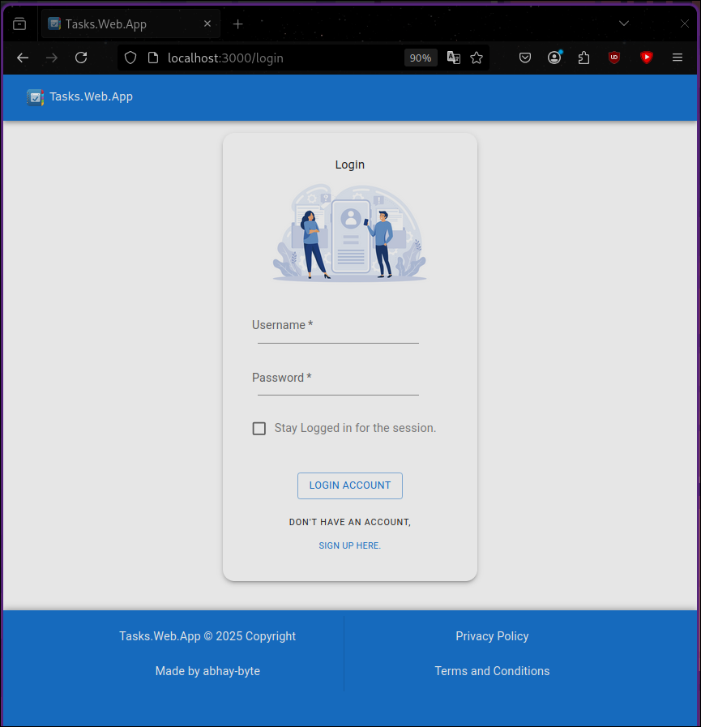

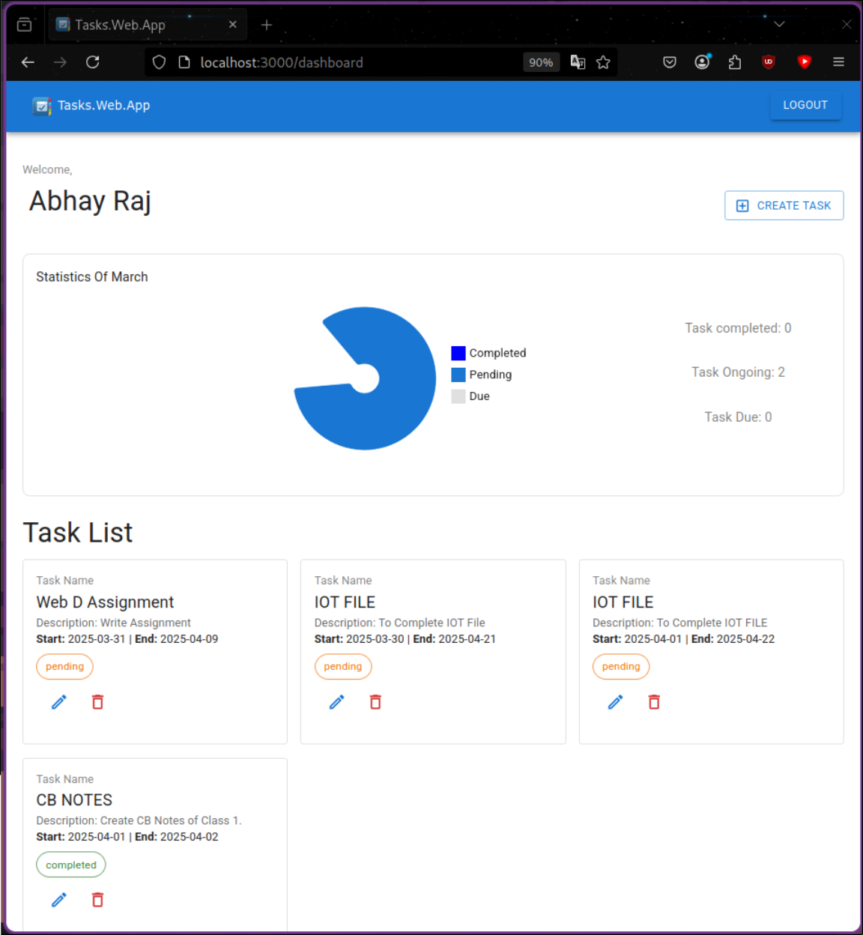

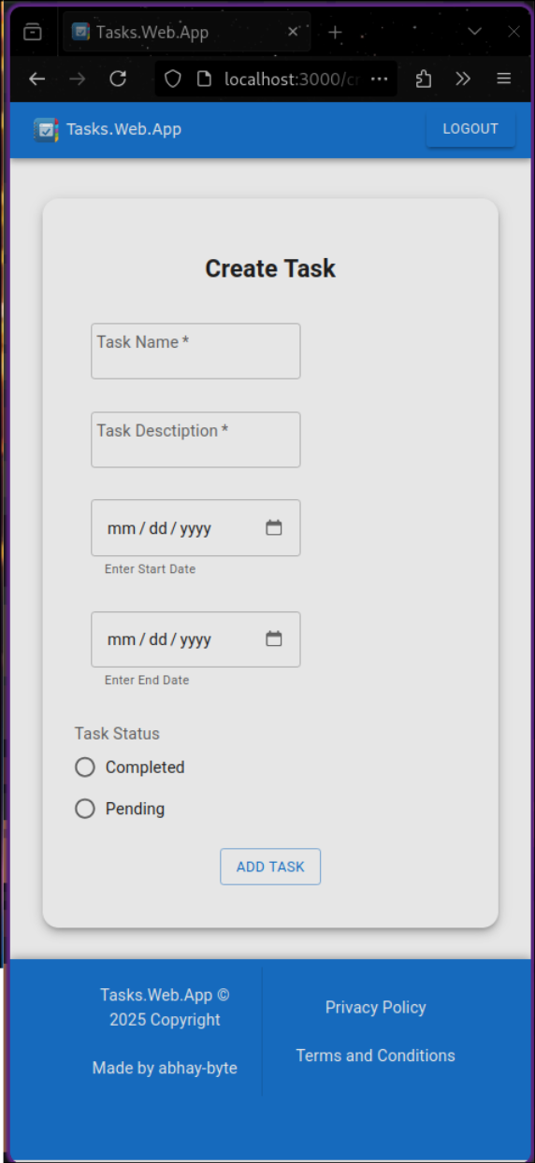

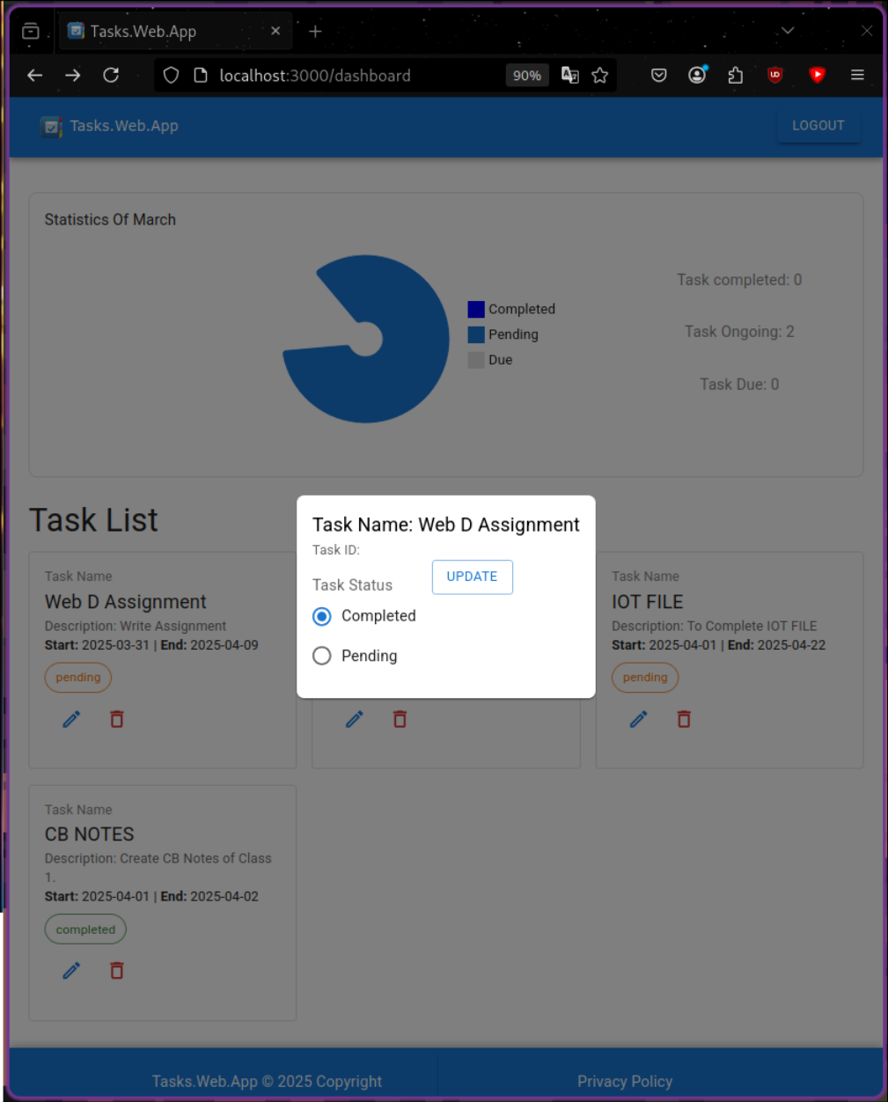

**Experiment 12**

**Aim:-** To create a Blogging platform in MERN.

Code:-

FRONTEND:

//p12/frontend/src/pages/Home.js

import React, { useEffect, useState } from "react";

import { Container, Card, CardContent, Typography, Button } from "@mui/material";

import axios from "axios";

const Home = () => {

const [posts, setPosts] = useState([]);

useEffect(() => {

axios.get("http://localhost:5000/api/posts")

.then(res => setPosts(res.data))

.catch(err => console.log(err));

}, []);

const deletePost = (id) => {

axios.delete(`http://localhost:5000/api/posts/${id}`)

.then(() => setPosts(posts.filter(post => post._id !== id)));

};

return (

<Container>

<h2>Blog Posts</h2>

{posts.map((post) => (

<Card key={post._id} style={{ marginBottom: "10px" }}>

<CardContent>

<Typography variant="h5">{post.title}</Typography>

<Typography variant="subtitle1">By {post.author}</Typography>

<Typography variant="body1">{post.body}</Typography>

<Button color="error" onClick={() => deletePost(post._id)}>Delete</Button>

</CardContent>

</Card>

))}

</Container>

);

};

export default Home;

//p12/frontend/src/pages/CreatePost.js

import React, { useState } from "react";

import { Container, TextField, Button } from "@mui/material";

import axios from "axios";

import { useNavigate } from "react-router-dom";

const CreatePost = () => {

const [post, setPost] = useState({ title: "", author: "", body: "" });

const navigate = useNavigate();

const handleChange = (e) => {

setPost({ ...post, [e.target.name]: e.target.value });

};

const submitPost = () => {

axios.post("http://localhost:5000/api/posts", post)

.then(() => navigate("/"))

.catch(err => console.log(err));

};

return (

<Container>

<h2>Create a New Post</h2>

<TextField fullWidth name="title" label="Title" onChange={handleChange} />

<TextField fullWidth name="author" label="Author" onChange={handleChange} />

<TextField fullWidth multiline rows={4} name="body" label="Body" onChange={handleChange} />

<Button variant="contained" color="primary" onClick={submitPost}>Submit</Button>

</Container>

);

};

export default CreatePost;

//p12/frontend/src/App.js

import { BrowserRouter as Router, Routes, Route, Link } from "react-router-dom";

import { AppBar, Toolbar, Button } from "@mui/material";

import Home from "./pages/Home";

import CreatePost from "./pages/CreatePost";

function App() {

return (

<Router>

<AppBar position="static">

<Toolbar>

<Button color="inherit" component={Link} to="/">Home</Button>

<Button color="inherit" component={Link} to="/create">New Post</Button>

</Toolbar>

</AppBar>

<Routes>

<Route path="/" element={<Home />} />

<Route path="/create" element={<CreatePost />} />

</Routes>

</Router>

);

}

export default App;

BACKEND:

//p12/backend/server.js

const express = require("express");

const mongoose = require("mongoose");

const cors = require("cors");

const dotenv = require("dotenv");

dotenv.config();

const app = express();

app.use(express.json());

app.use(cors());

mongoose.connect(process.env.MONGO_URI, { useNewUrlParser: true, useUnifiedTopology: true })

.then(() => console.log("MongoDB Connected"))

.catch(err => console.log(err));

const postRoutes = require("./routes/postRoutes");

app.use("/api/posts", postRoutes);

app.listen(5000, () => console.log("Server running on port 5000"));

//p12/backend/routes/postRoutes.js

const express = require("express");

const router = express.Router();

const Post = require("../models/Post");

// Get all posts

router.get("/", async (req, res) => {

const posts = await Post.find();

res.json(posts);

});

// Create a post

router.post("/", async (req, res) => {

const { title, author, body } = req.body;

const newPost = new Post({ title, author, body });

await newPost.save();

res.json(newPost);

});

// Delete a post

router.delete("/:id", async (req, res) => {

await Post.findByIdAndDelete(req.params.id);

res.json({ message: "Post deleted" });

});

module.exports = router;

//p12/backend/models/Post.js

const mongoose = require("mongoose");

const postSchema = new mongoose.Schema({

title: String,

author: String,

body: String

});

module.exports = mongoose.model("Post", postSchema);

Output:-

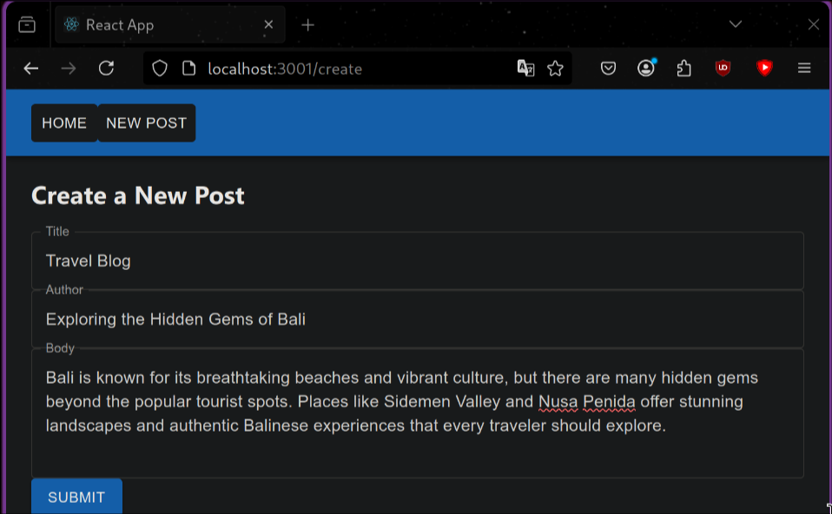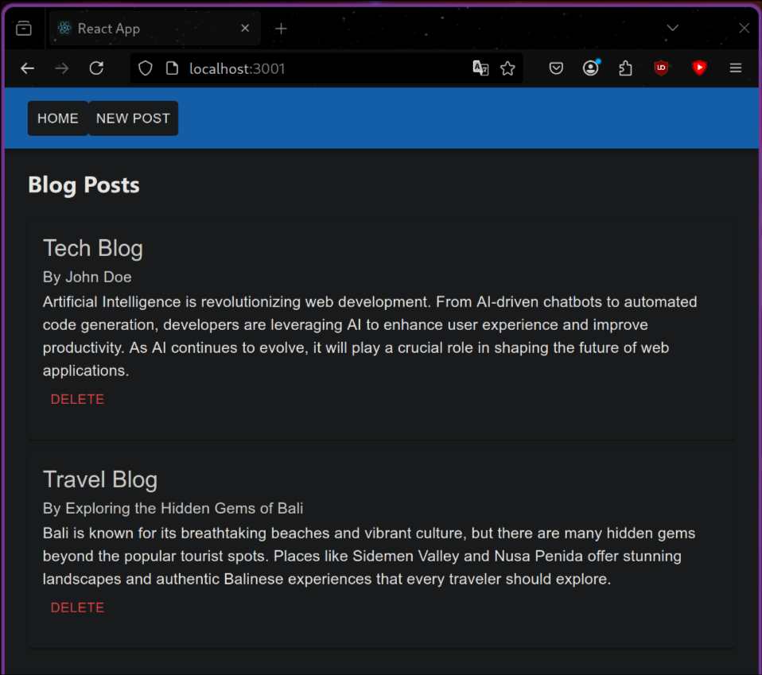

**Experiment 13**

**Aim:-** To create a Social media platform in MERN.

Code:-

FRONTEND:

//p13/social-media-app/frontend/src/App.js

import { BrowserRouter as Router, Route, Routes } from "react-router-dom";

import Home from "./pages/Home";

import Post from "./pages/Post";

function App() {

return (

<Router>

<Routes>

<Route path="/" element={<Home />} />

<Route path="/post" element={<Post />} />

</Routes>

</Router>

);

}

export default App;

//p13/social-media-app/frontend/src/pages/Home.js

import { useEffect, useState } from "react";

import axios from "axios";

import { Container, Typography, Card, CardContent, Button } from "@mui/material";

import { useNavigate } from "react-router-dom";

const Home = () => {

const [posts, setPosts] = useState([]);

const navigate = useNavigate();

useEffect(() => {

axios.get("http://localhost:5000/posts")

.then(res => setPosts(res.data))

.catch(err => console.error(err));

}, []);

return (

<Container>

<Typography variant="h4" sx={{ my: 2 }}>All Posts</Typography>

<Button variant="contained" onClick={() => navigate("/post")}>Create Post</Button>

{posts.map(post => (

<Card key={post._id} sx={{ my: 2 }}>

<CardContent>

<Typography>{post.content}</Typography>

</CardContent>

</Card>

))}

</Container>

);

};

export default Home;

//p13/social-media-app/frontend/src/pages/Post.js

import { useState } from "react";

import axios from "axios";

import { Container, TextField, Button, Typography } from "@mui/material";

import { useNavigate } from "react-router-dom";

const Post = () => {

const [content, setContent] = useState("");

const navigate = useNavigate();

const handleSubmit = async () => {

if (!content) return;

await axios.post("http://localhost:5000/posts", { content });

navigate("/");

};

return (

<Container>

<Typography variant="h4" sx={{ my: 2 }}>Create Post</Typography>

<TextField

fullWidth

label="What's on your mind?"

value={content}

onChange={(e) => setContent(e.target.value)}

sx={{ my: 2 }}

/>

<Button variant="contained" onClick={handleSubmit}>Post</Button>

</Container>

);

};

export default Post;

BACKEND:

//p13/social-media-app/backend/server.js

require("dotenv").config();

const express = require("express");

const mongoose = require("mongoose");

const cors = require("cors");

const app = express();

// Middleware

app.use(cors());

app.use(express.json());

// MongoDB Connection

mongoose

.connect(process.env.MONGO_URI, { useNewUrlParser: true, useUnifiedTopology: true })

.then(() => console.log("MongoDB Connected"))

.catch((err) => console.log(err));

// Routes

app.use("/posts", require("./routes/postRoutes"));

// Start Server

const PORT = process.env.PORT || 5000;

app.listen(PORT, () => console.log(`Server running on port ${PORT}`));

//p13/social-media-app/backend/models/Post.js

const mongoose = require("mongoose");

const PostSchema = new mongoose.Schema({

content: { type: String, required: true },

createdAt: { type: Date, default: Date.now },

});

module.exports = mongoose.model("Post", PostSchema);

//p13/social-media-app/backend/routes/postRoutes.js

const express = require("express");

const router = express.Router();

const Post = require("../models/Post");

// Create Post

router.post("/", async (req, res) => {

try {

const newPost = new Post({ content: req.body.content });

await newPost.save();

res.status(201).json(newPost);

} catch (err) {

res.status(500).json({ error: err.message });

}

});

// Get All Posts

router.get("/", async (req, res) => {

try {

const posts = await Post.find().sort({ createdAt: -1 });

res.json(posts);

} catch (err) {

res.status(500).json({ error: err.message });

}

});

// Delete Post

router.delete("/:id", async (req, res) => {

try {

await Post.findByIdAndDelete(req.params.id);

res.json({ message: "Post deleted" });

} catch (err) {

res.status(500).json({ error: err.message });

}

});

module.exports = router;

Output:-

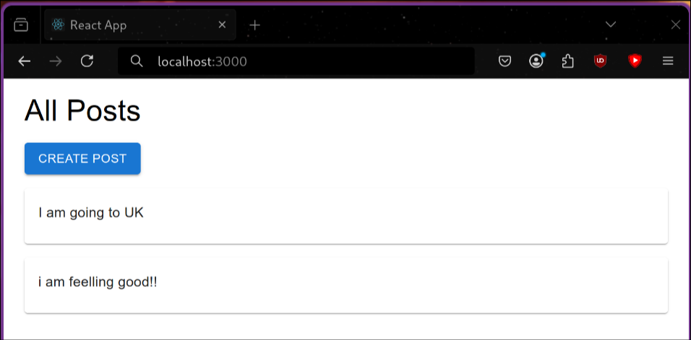

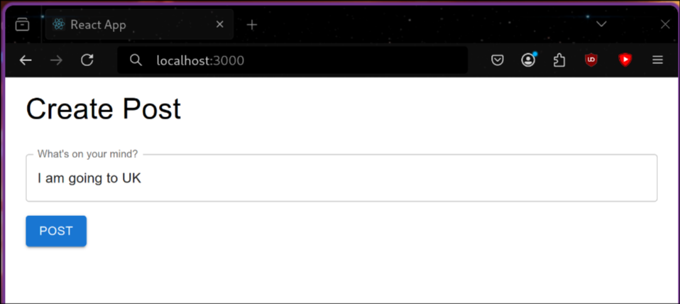

**Experiment 14**

**Aim:-** To create a Weather Forecasting App.

Code:-

FRONTEND:

//p14/weather-app/frontend/src/App.js

import Weather from "./components/Weather";

function App() {

return <Weather />;

}

export default App;

//p14/weather-app/frontend/src/components/Weather.js

import { useEffect, useState } from "react";

import axios from "axios";

import { Container, Typography, Card, CardContent, CircularProgress } from "@mui/material";

const API_KEY = "2984a11f27cc4183f0e09bec287a72be"; // Replace with your API Key

const CITY = "New Delhi";

const API_URL = `https://api.openweathermap.org/data/2.5/weather?q=${CITY}&units=metric&appid=${API_KEY}`;

const Weather = () => {

const [weather, setWeather] = useState(null);

const [loading, setLoading] = useState(true);

useEffect(() => {

axios.get(API_URL)

.then(res => {

setWeather(res.data);

setLoading(false);

})

.catch(err => console.error(err));

}, []);

return (

<Container sx={{ textAlign: "center", mt: 5 }}>

<Typography variant="h4">Weather Forecast - New Delhi</Typography>

{loading ? (

<CircularProgress sx={{ mt: 3 }} />

) : (

<Card sx={{ mt: 3, p: 3, maxWidth: 400, mx: "auto" }}>

<CardContent>

<Typography variant="h5">{weather.name}</Typography>

<Typography variant="h6">{weather.weather[0].description}</Typography>

<Typography variant="h4">{weather.main.temp}°C</Typography>

<Typography>Humidity: {weather.main.humidity}%</Typography>

<Typography>Wind: {weather.wind.speed} m/s</Typography>

</CardContent>

</Card>

)}

</Container>

);

};

export default Weather;

Output:-

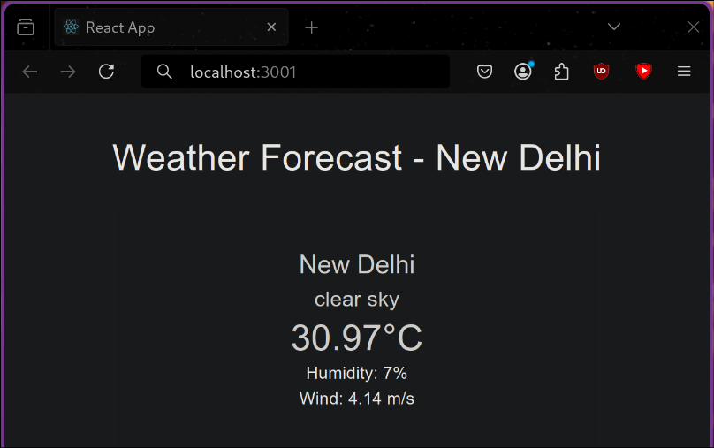

**Experiment 15**

**Aim:-** Bookstore Library and Stock-Keeping App

Code:-

FRONTEND:

//p15/bookstore-app/frontend/src/App.js

import { BrowserRouter as Router, Routes, Route } from "react-router-dom";

import BookList from "./components/BookList";

import StockManager from "./components/StockManager";

import { Container, AppBar, Toolbar, Typography, Button } from "@mui/material";

import { Link } from "react-router-dom";

function App() {

return (

<Router>

<Container>

<AppBar position="static">

<Toolbar>

<Typography variant="h6" sx={{ flexGrow: 1 }}>Bookstore</Typography>

<Button color="inherit" component={Link} to="/">Library</Button>

<Button color="inherit" component={Link} to="/stock">Stock Manager</Button>

</Toolbar>

</AppBar>

<Routes>

<Route path="/" element={<BookList />} />

<Route path="/stock" element={<StockManager />} />

</Routes>

</Container>

</Router>

);

}

export default App;

//p15/bookstore-app/frontend/src/components/BookList.js

import { useEffect, useState } from "react";

import axios from "axios";

import { List, ListItem, ListItemText, Typography, Container } from "@mui/material";

const BookList = () => {

const [books, setBooks] = useState([]);

useEffect(() => {

axios.get("http://localhost:5000/api/books")

.then(res => setBooks(res.data))

.catch(err => console.error(err));

}, []);

return (

<Container>

<Typography variant="h4" sx={{ my: 3 }}>Library Books</Typography>

<List>

{books.map((book) => (

<ListItem key={book._id}>

<ListItemText primary={`${book.title} by ${book.author}`} secondary={`Genre: ${book.genre}, Stock: ${book.stock}`} />

</ListItem>

))}

</List>

</Container>

);

};

export default BookList;

//p15/bookstore-app/frontend/src/components/StockManager.js

import { useState } from "react";

import axios from "axios";

import { TextField, Button, Container, Typography } from "@mui/material";

const StockManager = () => {

const [book, setBook] = useState({ title: "", author: "", genre: "", publishedYear: "", stock: "" });

const handleChange = (e) => {

setBook({ ...book, [e.target.name]: e.target.value });

};

const handleSubmit = () => {

axios.post("http://localhost:5000/api/books", book)

.then(() => alert("Book added successfully"))

.catch(err => console.error(err));

};

return (

<Container>

<Typography variant="h4" sx={{ my: 3 }}>Stock Management</Typography>

<TextField label="Title" name="title" fullWidth margin="normal" onChange={handleChange} />

<TextField label="Author" name="author" fullWidth margin="normal" onChange={handleChange} />

<TextField label="Genre" name="genre" fullWidth margin="normal" onChange={handleChange} />

<TextField label="Published Year" name="publishedYear" fullWidth margin="normal" onChange={handleChange} />

<TextField label="Stock" name="stock" fullWidth margin="normal" onChange={handleChange} />

<Button variant="contained" color="primary" sx={{ mt: 2 }} onClick={handleSubmit}>Add Book</Button>

</Container>

);

};

export default StockManager;

BACKEND:

//p15/bookstore-app/backend/server.js

const express = require("express");

const mongoose = require("mongoose");

const cors = require("cors");

require("dotenv").config();

const app = express();

app.use(cors());

app.use(express.json());

// Connect to MongoDB

mongoose.connect(process.env.MONGO_URI, { useNewUrlParser: true, useUnifiedTopology: true })

.then(() => console.log("MongoDB Connected"))

.catch(err => console.error(err));

// Import book routes

const bookRoutes = require("./routes/bookRoutes");

app.use("/api/books", bookRoutes);

const PORT = process.env.PORT || 5000;

app.listen(PORT, () => console.log(`Server running on port ${PORT}`));

//p15/bookstore-app/backend/routes/bookRoutes.js

const express = require("express");

const { getBooks, addBook, deleteBook } = require("../controllers/bookController");

const router = express.Router();

router.get("/", getBooks);

router.post("/", addBook);

router.delete("/:id", deleteBook);

module.exports = router;

///home/abhay/code/WEBD/p15/bookstore-app/backend/models/Book.js

const mongoose = require("mongoose");

const BookSchema = new mongoose.Schema({

title: String,

author: String,

genre: String,

publishedYear: Number,

stock: Number

});

module.exports = mongoose.model("Book", BookSchema);

//p15/bookstore-app/backend/controllers/bookController.js

const Book = require("../models/Book");

// Get all books

exports.getBooks = async (req, res) => {

const books = await Book.find();

res.json(books);

};

// Add a new book

exports.addBook = async (req, res) => {

const newBook = new Book(req.body);

await newBook.save();

res.json({ message: "Book added successfully" });

};

// Delete a book

exports.deleteBook = async (req, res) => {

await Book.findByIdAndDelete(req.params.id);

res.json({ message: "Book deleted" });

};

Output:-

